

Faculty of Science and Engineering

School of Computing and Information Science

**Module MOD003263:**

**Software Engineering**

**Element 010**

**Report**

**SID NUMBER: REMOVED**

Trimester 1 – 2023

Submission deadline: REMOVED

Table of Contents

1. Introduction 4

2. Problem Definition Document 5

2.1 Definition of aims 5

2.2 System Requirements 5

2.3 Project Plan 5

2.4 Resources Used 7

2.5 User Stories 7

3. Software Design 9

3.1 Wireframe 9

3.2 Database design: CitiSoftDatabase.mdf 17

3.2.1 Entiry Relationship Diagram 17

3.2.2 Extended Entity Relationship Diagram 18

3.2.3 Table Schema 20

3.3 Database design: Functionality.mdf 24

3.3.1 Entity Relationship Diagram 24

3.3.2 Extended Entity Relationship Diagram 25

3.3.3 Table Schema 26

3.4 Software Design 30

3.4.1 Use Case Diagram 30

3.4.2 Class Diagram 38

3.4.3 Sequence Diagrams 39

4. Software Development Documentation 43

4.1 User story 1: As a (Admin, Manager) I can remove the client from the database 43

4.1.1 Design 43

4.1.2 Implementation 48

4.2 User story 2: As a (Admin, Manager, User) I can view and add the client to the Problem History 67

4.2.1 Design 67

4.2.2 Implementation 70

4.3 User story 4: As a (Admin), I can add or remove vendor documents 75

4.3.1 Design 75

4.3.2 Implementation 78

4.4 User story 3: As a (Admin, Manager, User), I can access vendor documents 83

4.4.1 Design 83

4.4.2 Implementation 86

5. Commits 92

6. Testing 97

7. Plan of the Software Maintenance 103

8. Conclusions 105

9. References 106

# Introduction

The work presented demonstrates the application of the knowledge and skills acquired from the Software Engineering module.

Every team member contributed collaboratively to the creation of a software application designed to assist Citisoft in inputting information into a centralized data repository, which houses crucial details about each vendor and their respective applications.

This software was made using Windows Forms framework and intended for use by anyone engaged in the review of these applications.

# Problem Definition Document

## Definition of aims

**The aim of the Vendor Application Inventory Platform project is to address critical challenges faced by financial services consultancies in the process of assisting companies to identify and select suitable technology solutions for their business needs. The primary goal of this project is to develop a centralized data repository that simplifies the management and access to crucial information related to various technology vendors and their offerings. This repository will store both structured and unstructured data, such as PDF documents, enabling authorized users to efficiently enter, update, and retrieve information. The project aims to create a user-friendly interface that streamlines data entry and information discovery, making it analogous to a user-friendly Amazon-like experience for financial services vendors.**

## System Requirements

The main system requirement needed to handle the required software application

1. PC running Windows 7 operating system or later versions
2. A keyboard to make an input to the application
3. A mouse or trackpad to interact with the application
4. An internet connection

## Project Plan

The choice to utilize the Waterfall methodology for developing the software application stemmed from its suitability for our team and project’s nature. With the Waterfall methodology, team members could engage in product development while having access to all the necessary requirements, given the thorough problem description.

During the development of this application, we were using Visual Studio as a primary IDE, and Windows Forms as a main Frame work.

Each member was able to participate in every element of development, from design to code.

## Resources Used

1. “Grammarly” cloud-based typing assistant, version 3.2.2.0
2. Internet browser “Safari”, version 17.0
3. Internet browser “Google Chrome”, version 117.0.5938.92
4. “Lucid chart”, version 3.6.1
5. Microsoft Visual Studio 2022, version 17.7
6. Version Control “GitHub”, version 3.10.2
7. Version Control “git”, version 2.33.0
8. Designing tool “Figma”, version 16.13.3
9. Designing website “wireframe.cc”

## User Stories

**Common to all roles:**

1. As an (Admin, Manager, User), I can view and search for Vendors and Software.
2. As an (Admin, Manager, User), I can access vendor documentss.
3. As an (Admin, Manager, User), I can leave comments and reviews for software.
4. As an (Admin, Manager, User), I can log in to the system.
5. As an (Admin, Manager, User), I can view the dashboard.
6. As an (Admin, Manager, User), I can open vendor links directly in a web browser.
7. As an (Admin, Manager, User), I can set up my password from my profile.
8. As an (Admin, Manager, User), I can view and add client problem history.

**Common to Admin and Manager:**

1. As an (Admin, Manager), I can create and update vendors and software.
2. As an (Admin, Manager), I can assign a set of rules to Users.
3. As an (Admin, Manager), I can remove clients from the database.

**Common to Manager and User:**

1. As a (Manager, User), I can request a forgotten password upon login.

**Only for Admin:**

1. As an Admin, I can remove vendors and software.
2. As an Admin, I can add or remove vendor documentss.
3. As an Admin, I can add or remove users and managers.
4. As an Admin, I can assign sets of rules to Managers and Users.
5. As an Admin, I can change or update database settings for all users.
6. As an Admin, I can approve forgotten password requests.

# Software Design

## 3.1 Wireframe

In this section, author shows several Wireframes that represent future pages of Citisoft application. On each page there are several colors for each figure that represents a control.

Button = grey

Text Box = dark grey

Label = transparent(white)

All other controls are labelled.

**Login page**

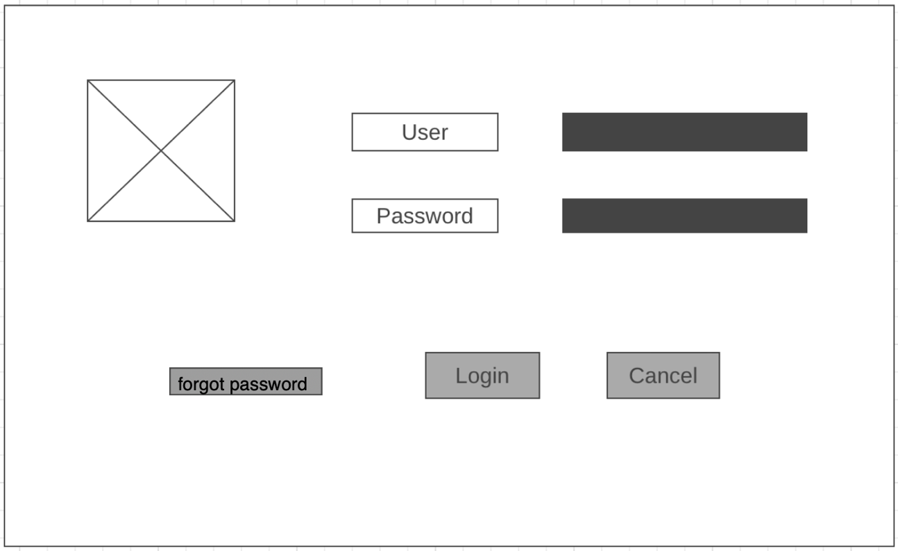

**Vendor/Vendor View page**

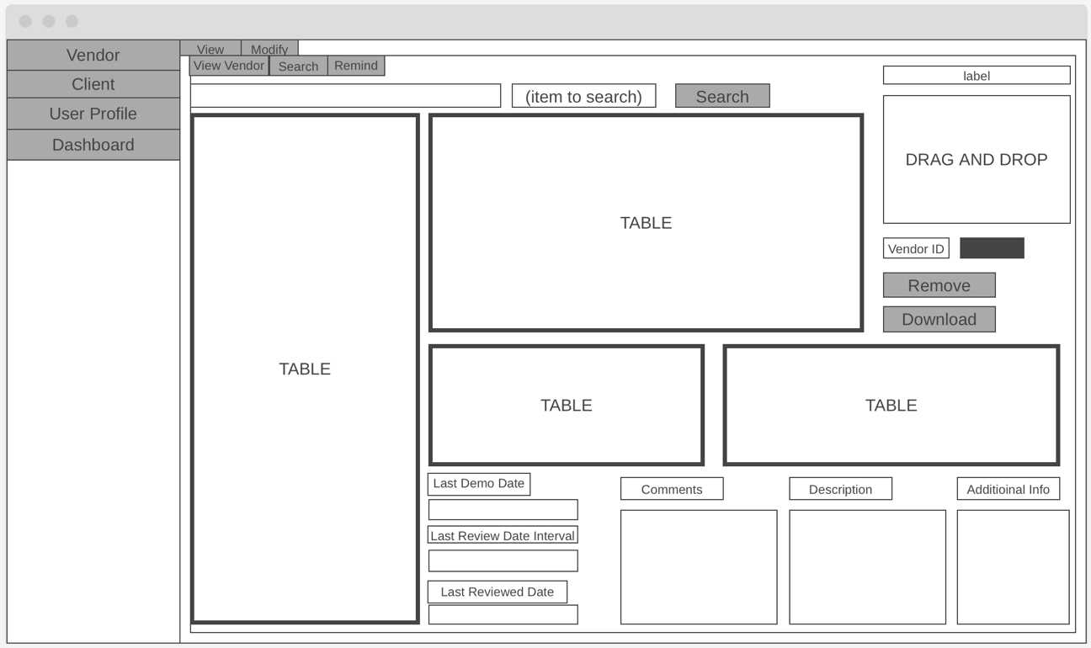

**Vendor/Modify/Add Vendor page**

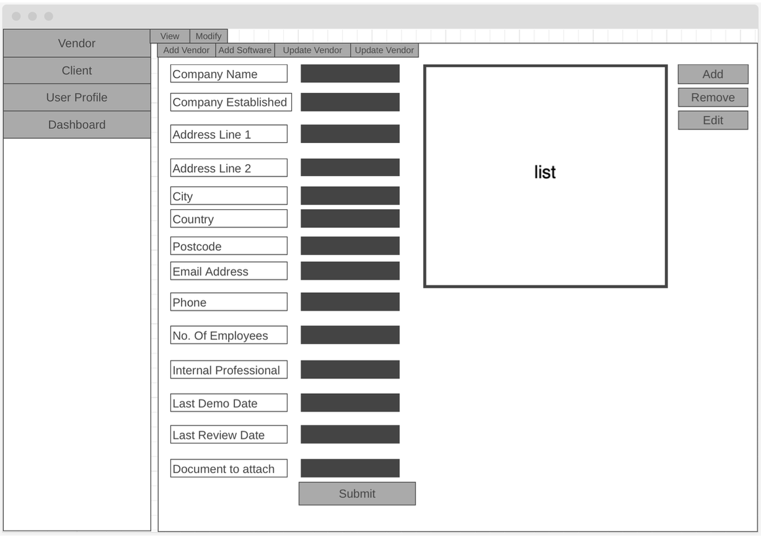

**Vendor/Modify/Add Software**

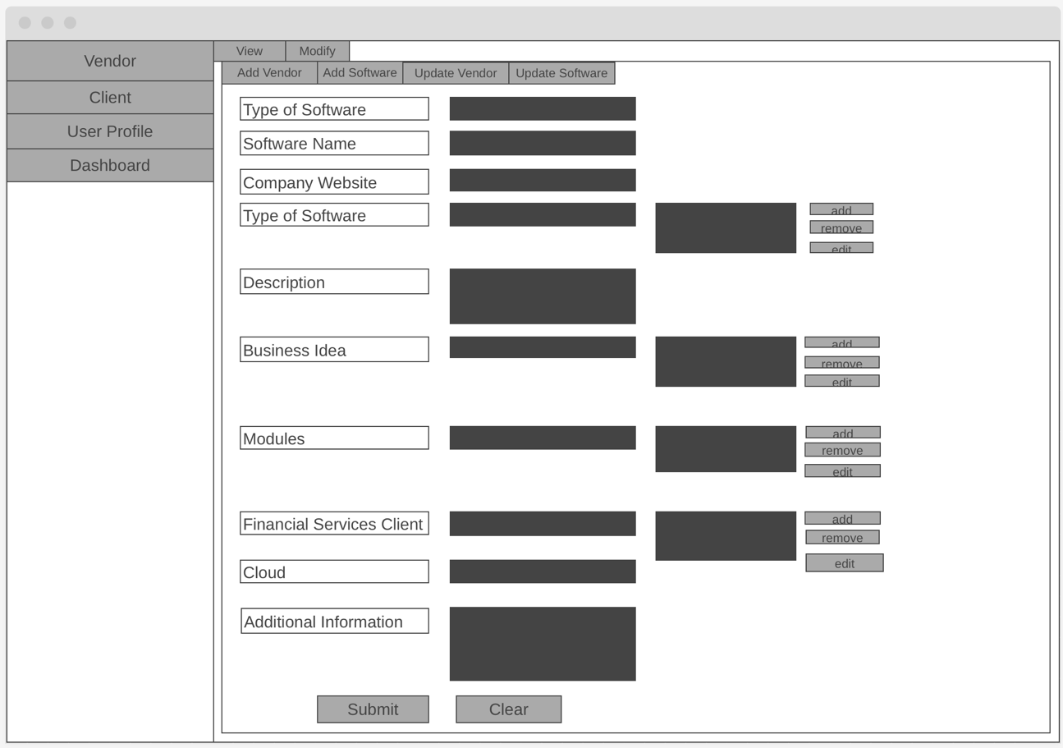

**Vendor/Modify/Update Vendor**

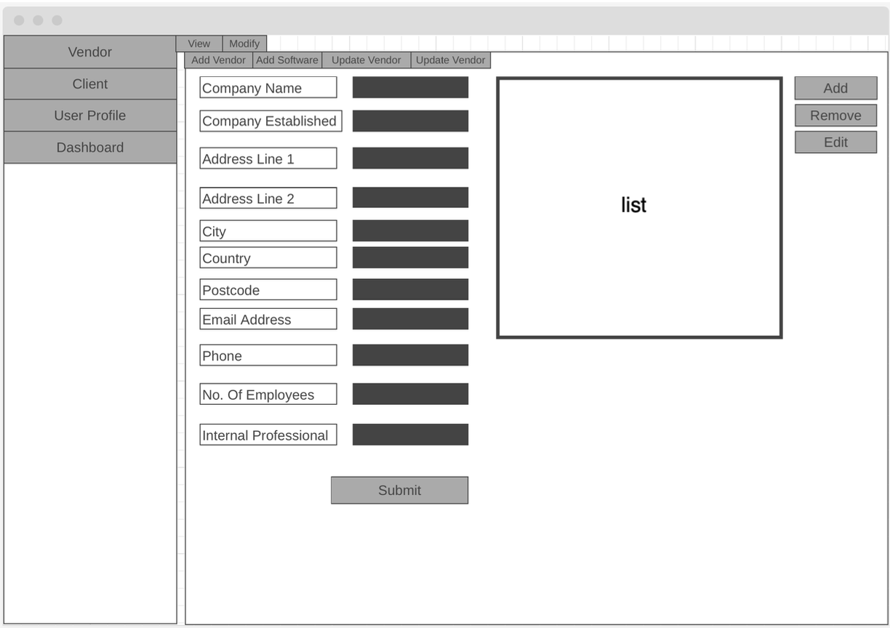

**Vendor/Modify/Update Software**

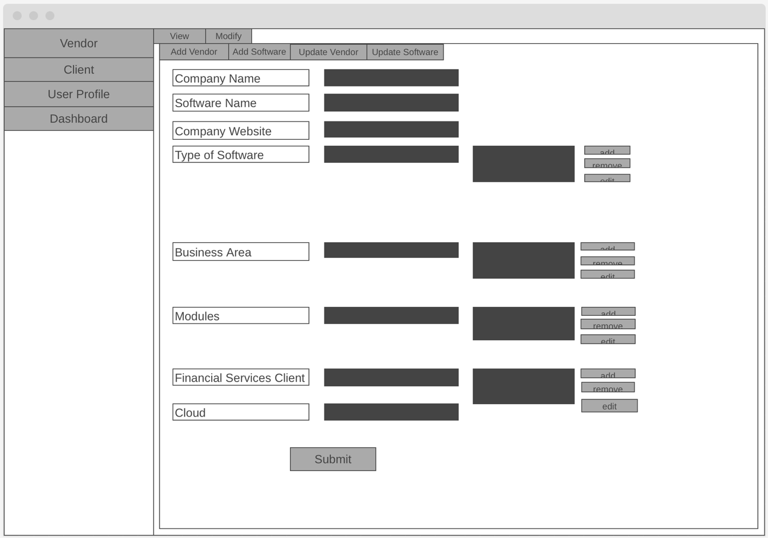

**Client/Client Problem History page**

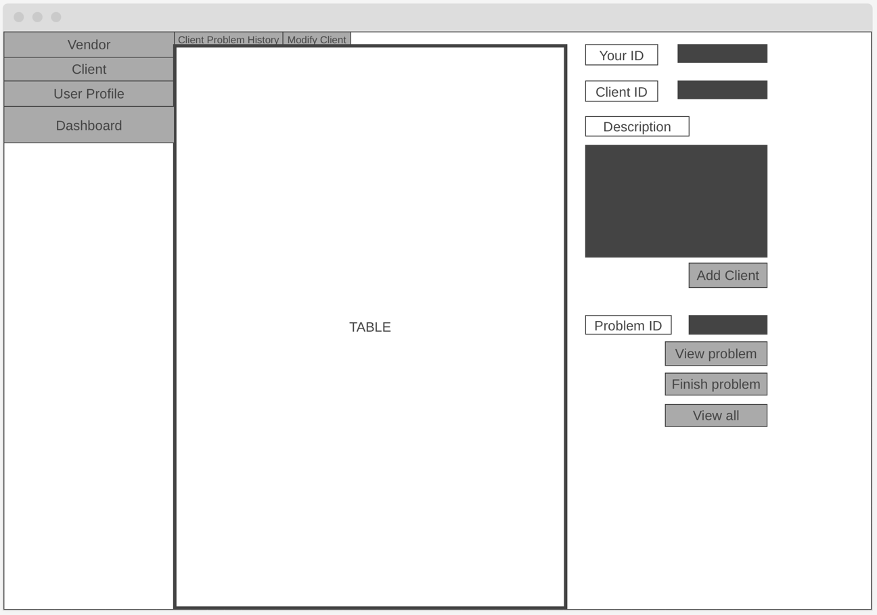

**Cliet/Modify Client page.**

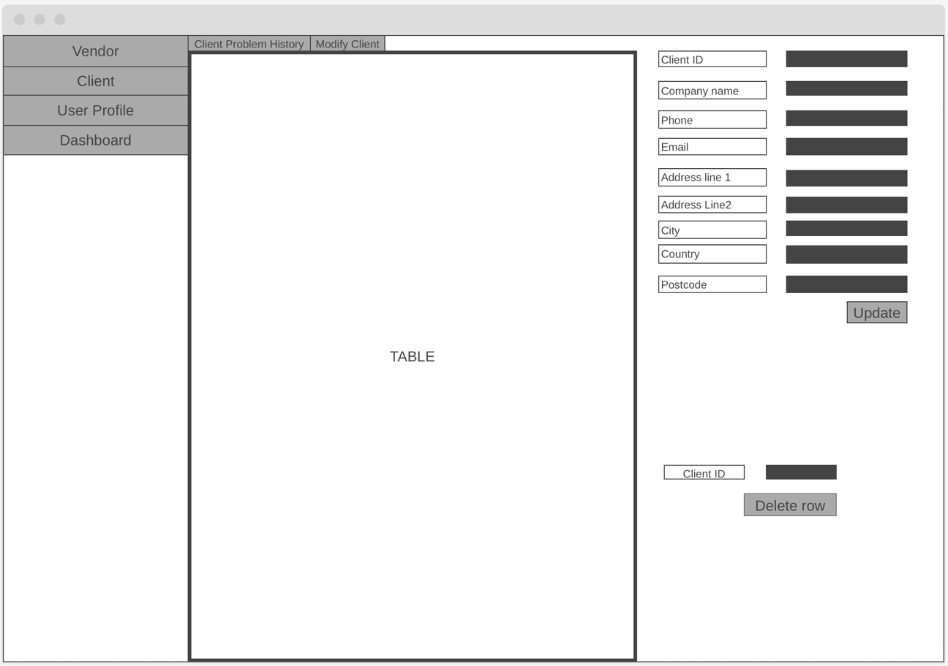

**User Profile page.**

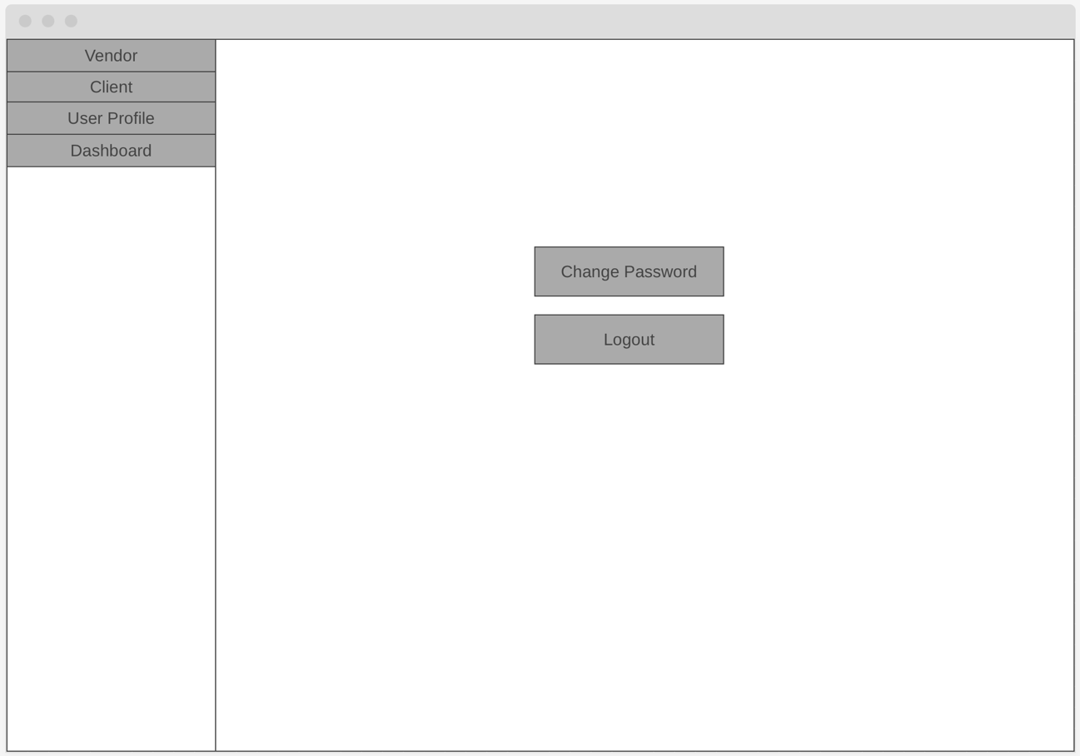

**Change Password window.**

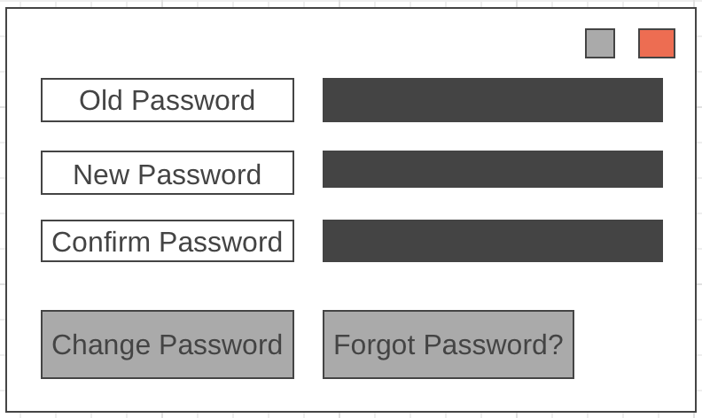

**Forgot Password window.**

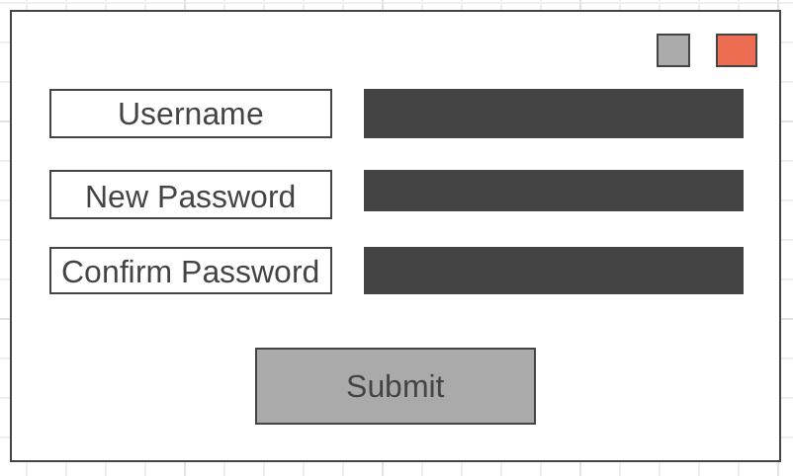

**Dashboard page.**

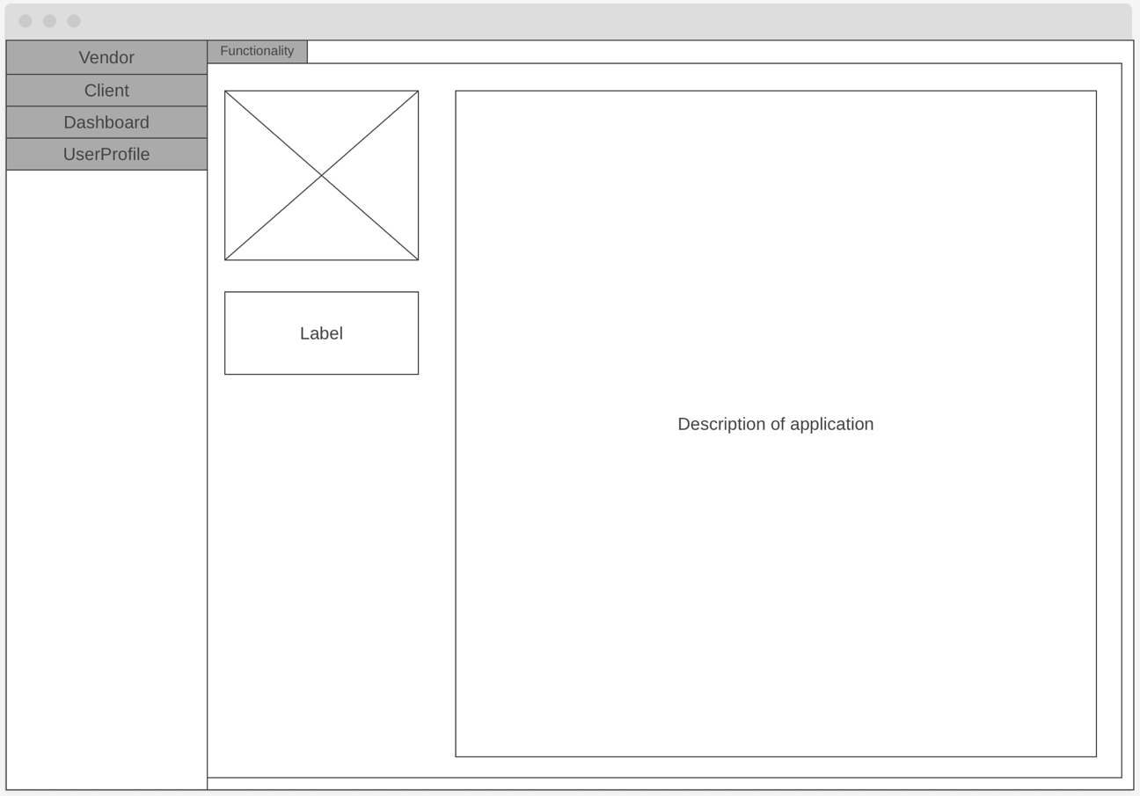

**Vendor/Register/PasswordRequests page.**

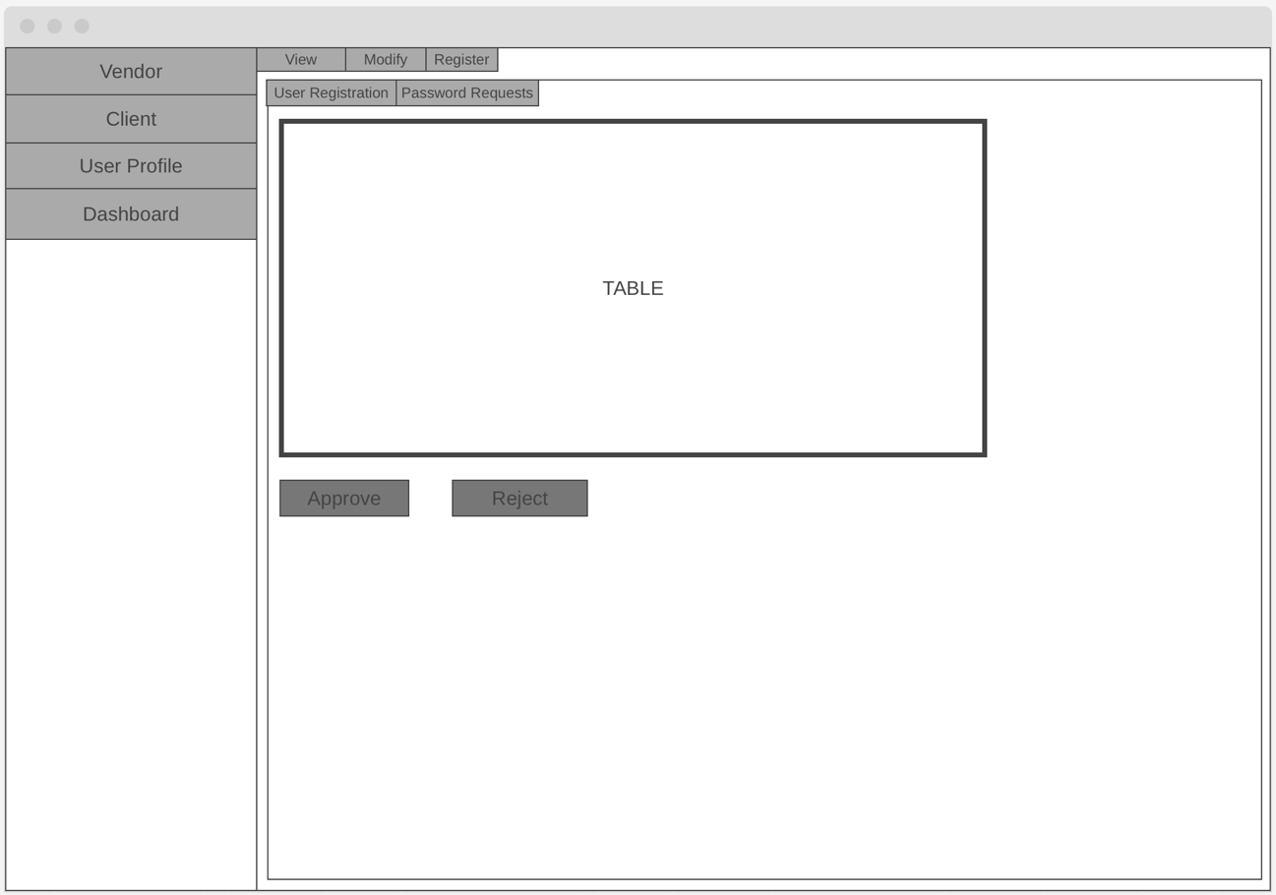

**Vendor/Register/User Registration**

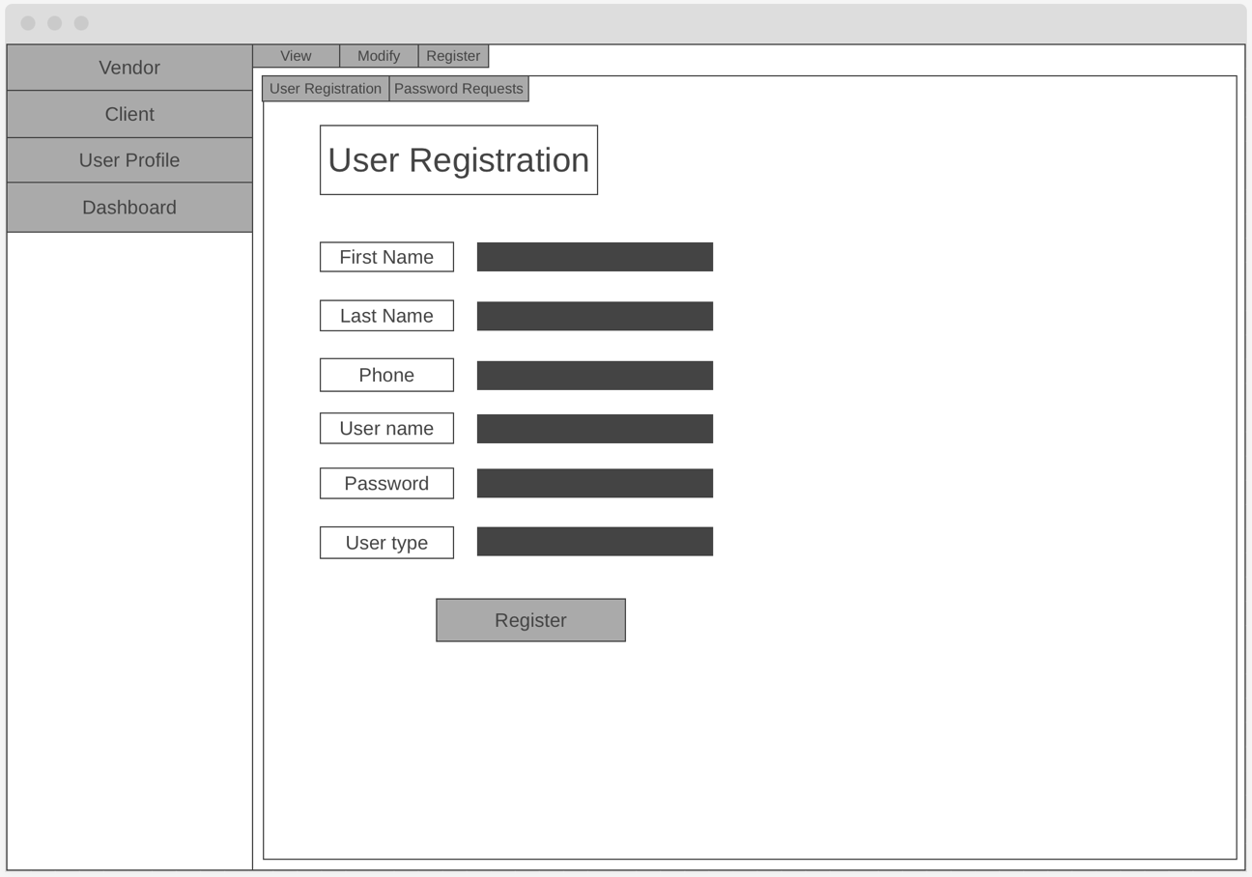

## 3.2 Database design: CitiSoftDatabase.mdf

### 3.2.1 Entiry Relationship Diagram

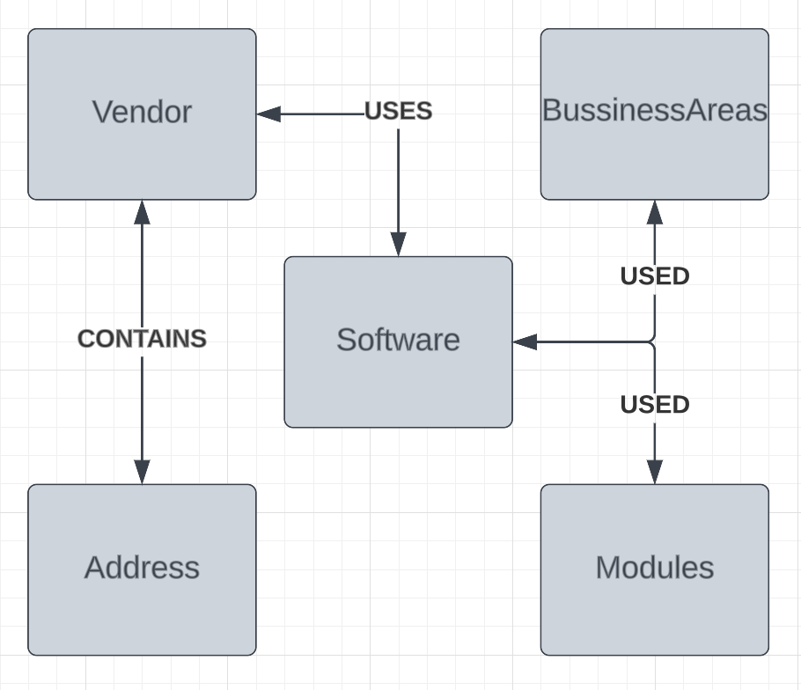

**Description**

The provided ERD has five tables that relate to each other:

* **Vendor** entity holds all information about vendor.
* **Address** entity saves the location of vendor.
* **Software** entity contains the software information that vendor uses.
* **BusinessAreas** entity holds the information of business areas.
* **Modules** entity contains the data related to modules.

### 3.2.2 Extended Entity Relationship Diagram

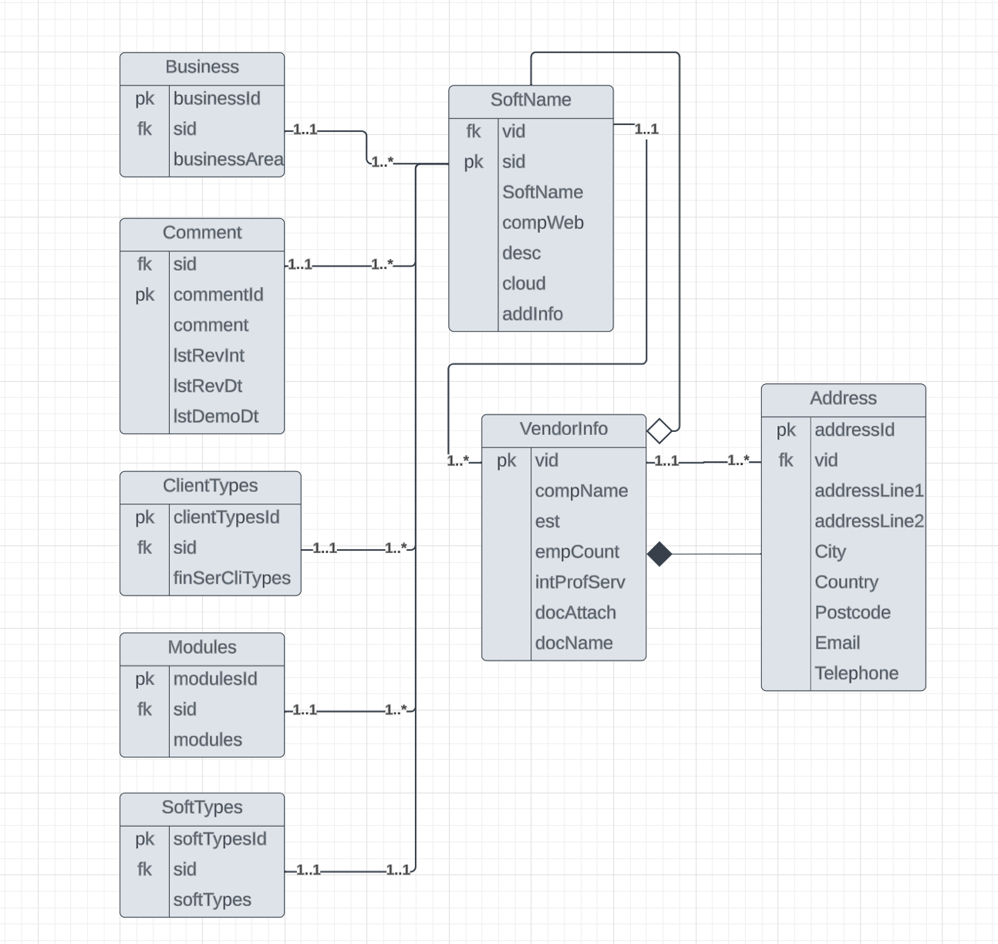

**Description**

Provided EERD contains all necessary attributes and tables to work with company’s data. VendorInfo table holds all information about the vendor, plus сonnected with an additional table: Address. These tables are needed to manage the searches and optimize and simplify the querying. Moreover, the remained tables are mandatory to maintain and store the information that will be added later when using the application.

Relationships among the tables were also added to show that some of the tables will be deleted or saved if the related table is deleted.

### 3.2.3 Table Schema

|  |  |  |  |
| --- | --- | --- | --- |
| VendorInfo | | | |
| Attribute name | Data type | Allow Nulls | Description |
| vid | identity(1, 1) | NO | Primary key |
| compName | varchar(20) | YES | Name of the company |
| est | smallint | YES | Store establishments |
| empCount | nvarchar(25) | YES | Stores number of employees |
| intProfServ | bit | YES | Stores international professional services |
| docAttach | varbinary(max) | YES | Stores a document data that was attached |
| docName | varchar(255) | YES | Store the document name |

|  |  |  |  |
| --- | --- | --- | --- |
| SoftTypes | | | |
| Attribute name | Data type | Allow Nulls | Description |
| softTypesId | int | NO | Primary key |
| sid | int | NO | Foreign key, references to the SoftName table’s sid primary key |
| softTypes | nvarchar(30) | NO | Stores software types |

|  |  |  |  |
| --- | --- | --- | --- |
| SoftName | | | |
| Attribute name | Data type | Allow Nulls | Description |
| vid | int | NO | Foreign key, references VendorInfo’s vid primary key |
| sid | int | NO | Primary key |
| SoftName | varchar(30) | YES | Stores software name |
| compWeb | varchar(40) | YES | Stores company’s website name |
| desc | nvarchar(255) | YES | Stores the description |
| cloud | nvarchar(10) | YES | Stores cloud name |
| addInfo | nvarchar(255) | YES | Stores additional information |

|  |  |  |  |
| --- | --- | --- | --- |
| Modules | | | |
| Attribute name | Data type | Allow Nulls | Description |
| moduleId | int | NO | Primary key |
| sid | int | NO | Foreign key, references to SoftName’s sid primary key |
| modules | nvarchar(30) | NO | Stores the modules |

|  |  |  |  |
| --- | --- | --- | --- |
| ClientTypes | | | |
| Attribute name | Data type | Allow Nulls | Description |
| clientTypesId | int | NO | Primary key |
| sid | int | NO | Foreign key, references to SoftName’s sid primary key |
| finSerCliTypes | nvarchar(30) | NO | Stores financial services client types |

|  |  |  |  |
| --- | --- | --- | --- |
| Address | | | |
| Attribute name | Data type | Allow Nulls | Description |
| addressId | int | NO | Primary key |
| vid | int | NO | Foreign key, references VerdorInfo’s vid primary key |
| addressLine1 | nvarchar(30) | YES | Stores address line 1 |
| addressLine2 | nvarchar(30) | YES | Stores address line 2 |
| city | nvarchar(20) | YES | Stores city name |
| country | nvarchar(20) | YES | Stores country name |
| postcode | nvarchar(12) | YES | Stores postcode |
| email | nvarchar(50) | YES | Stores email |
| telephone | nvarchar(12) | YES | Stores telephone |
| Comments | | | |
| Attribute name | Data type | Allow Nulls | Description |
| sid | int | NO | Foreign key, references to SoftName’s primary key |
| commentId | int | NO | Primary key |
| comment | nvarchar(50) | NO | Stores the comment |
| lstDemoDt | data | YES | Stores last demo date |
| lstRevInt | smallint | YES | Stores last Review interval |
| lstRevDt | date | YES | Stores last Review date |

## 3.3 Database design: Functionality.mdf

### 3.3.1 Entity Relationship Diagram

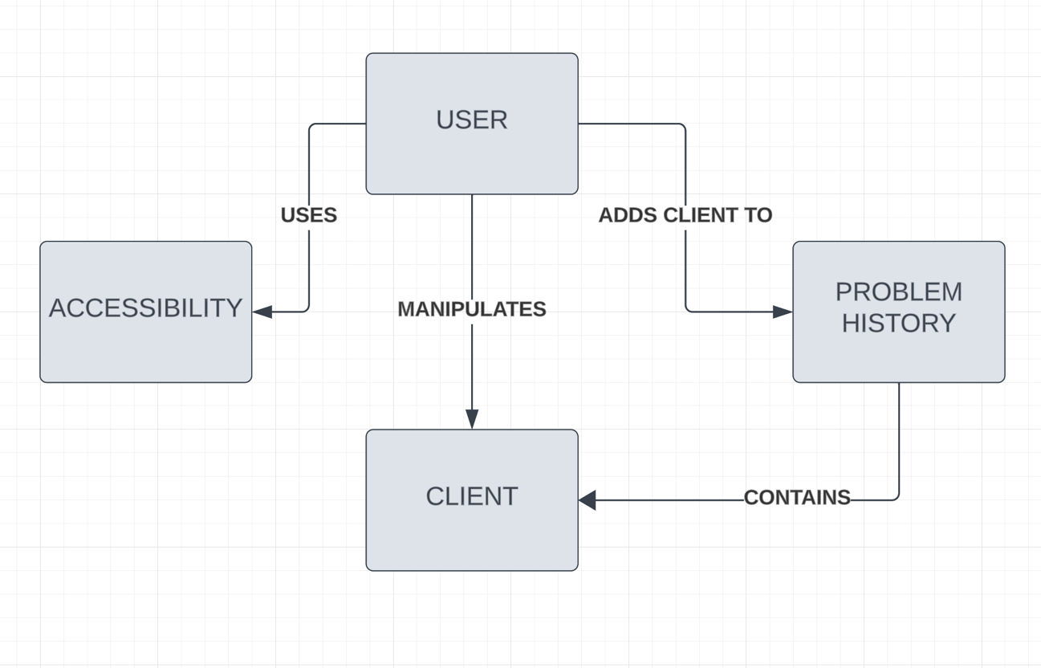

**Description**

The provided ERD has four tables that relate to each other:

* **User** entity contains information about user
* **Problem** History entity saves all problems of clients
* **Client** entity holds all information about clients
* **Accessibility** entity helps to manipulate

### 3.3.2 Extended Entity Relationship Diagram

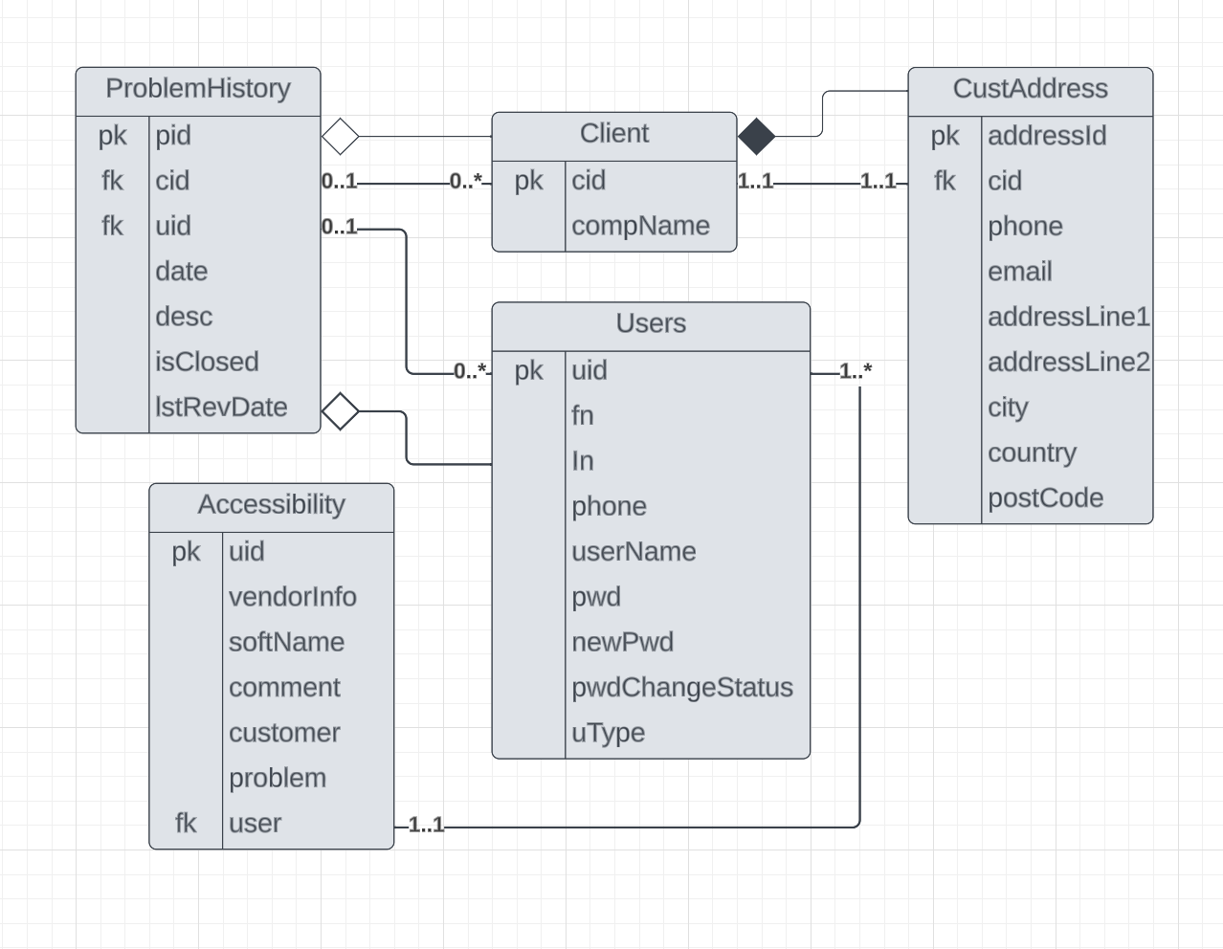

**Description**

Provided EERD contains all necessary attributes and tables to work with client’s data. ProblemHistory table holds all information about the problem clients have, plus сonnected with two tables: Client and User. These tables are needed to manage the searches and optimize and simplify the querying. Moreover, the remained tables are mandatory to maintain and store the information that will be used in problem history.

Relationships among the tables were also added to show that some of the tables will be deleted or saved if the related table is deleted.

### 3.3.3 Table Schema

|  |  |  |  |
| --- | --- | --- | --- |
| Users | | | |
| Attribute name | Data type | Allow Nulls | Description |
| uid | int | NO | Primary key |
| fn | nvarchar(30) | NO | Stores first name |
| ln | nvarchar(30) | NO | Stores last name |
| phone | nvarchar(15) | NO | Stores phone |
| userName | nvarchar(50) | NO | Stores email/user name |
| pwd | nvarchar(30) | NO | Stores password |
| uType | int | NO | Stores numerical reference to user type: (Admin:1, Manager:2, User:3) |
| newPwd | nvarchar(50) | NO | Stores email/user name |
| pwdChangeStatus | nvarchar(50) | NO | Stores email/user name |

|  |  |  |  |
| --- | --- | --- | --- |
| ProblemHistory | | | |
| Attribute name | Data type | Allow Nulls | Description |
| pid | int | NO | Primary key |
| cid | int | YES | Foreign key, references Client’s cid primary key |
| uid | int | YES | Foreign key, references User’s uid primary key |
| date | date | YES | Stores the date when problem was created |
| desc | nvarchar(255) | YES | Stores description of the problem |
| isClosed | bit | YES | Stores the status of the problem, 1= finished, 0 = still in progress |
| lstRevDate | date | YES | Stores last review date |

|  |  |  |  |
| --- | --- | --- | --- |
| CustAddress | | | |
| Attribute name | Data type | Allow Nulls | Description |
| addressId | int | NO | Primary key |
| cid | int | NO | Foreign key, references Client’s cid primary key |
| phone | nvarchar(15) | YES | Stores phone number |
| email | nvarchar(30) | YES | Stores email |
| addressLine1 | nvarchar(30) | YES | Stores address line 1 |
| addressLine2 | nvarchar(30) | YES | Stores addres line 2 |
| city | nvarchar(30) | YES | Stores city name |
| country | nvarchar(30) | YES | Stores country name |
| postCode | nvarchar(30) | YES | Stores post code |

|  |  |  |  |
| --- | --- | --- | --- |
| Client | | | |
| Attribute name | Data type | Allow Nulls | Description |
| cid | int | NO | Primary key |
| compName | nchar(10) | NO | Stores company name |

|  |  |  |  |
| --- | --- | --- | --- |
| Accessibility | | | |
| Attribute name | Data type | Allow Nulls | Description |
| uid | int | NO | Primary key |
| vendorInfo | tinyint | YES | Stores information about vendor |
| softName | tinyint | YES | Stores software name |
| comment | tinyint | YES | Stores comment |
| customer | tinyint | YES | Stores customer name |
| problem | tinyint | YES | Stores problem |
| user | tinyint | YES | Foreign key, references to User’s uid primary key |

## 3.4 Software Design

### 3.4.1 Use Case Diagram

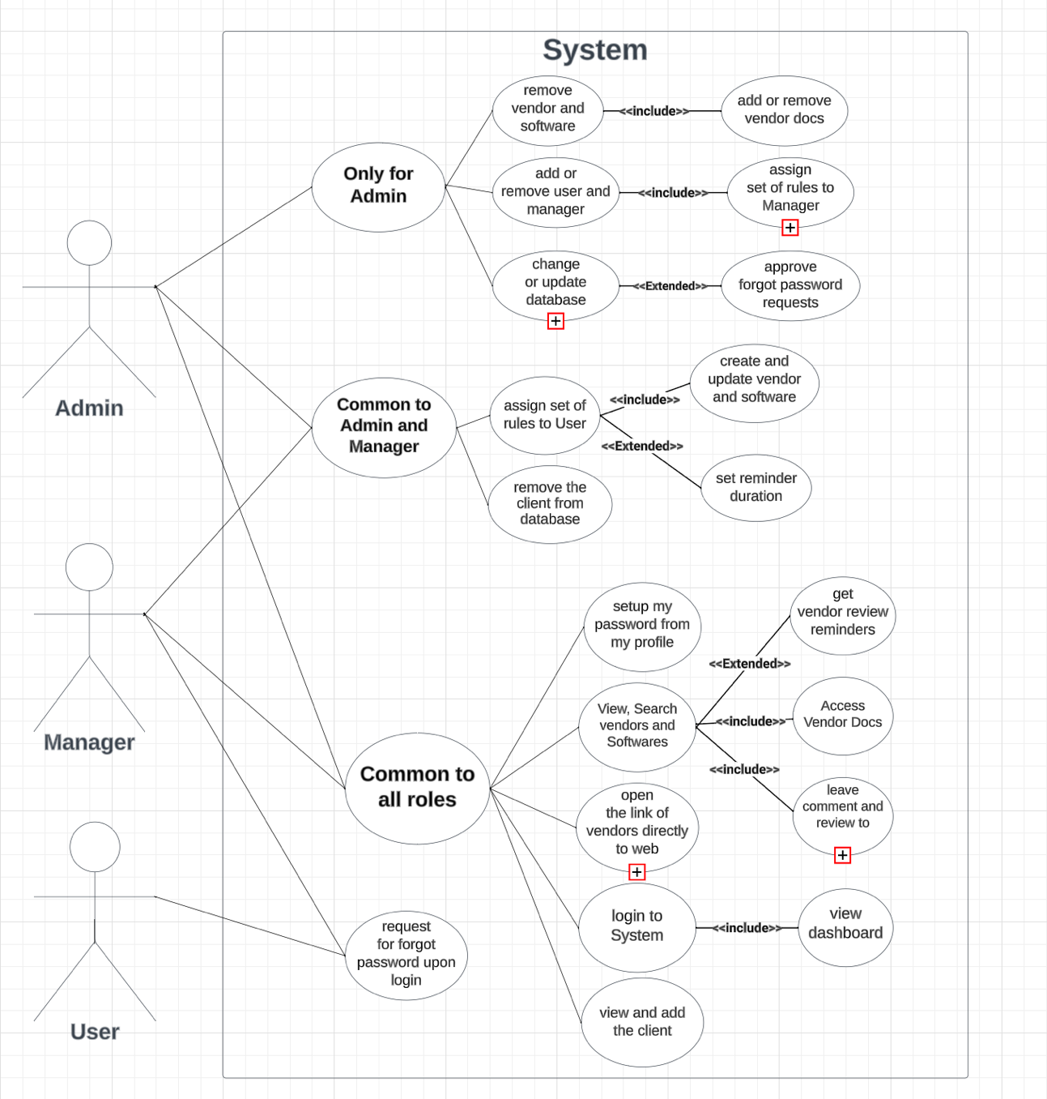

|  |  |
| --- | --- |
| **Use Case Name** | Remove vendor and software |
| **Participating Actors** | Admin |
| **Flow of Events** | 1. Move to Vendor remove page 2. Choose Vendor 3. Press “Delete” button 4. Vendor is removed from the database |
| **Alternative Flows** | 2a non-existing Vendor ID provided  3a Vendor ID was not chosen |
| **Entry Conditions** | Admin must know Vendor ID |
| **Exit Conditions** | Vendor is deleted/removed from the database |

|  |  |
| --- | --- |
| **Use Case Name** | Add or remove user and manager |
| **Participating Actors** | Admin |
| **Flow of Events** | 1. Move to Modify user page 2. Provide User ID 3. Press “Delete row” button 4. User is deleted |
| **Alternative Flows** | 2a non-existing User ID is provided  3a User ID was not provieded |
| **Entry Conditions** | Admin must know User ID |
| **Exit Conditions** | User is deleted |

|  |  |
| --- | --- |
| **Use Case Name** | Change or update database |
| **Participating Actors** | Admin |
| **Flow of Events** | 1. Move to Vendor View page 2. Choose data to update/delete/add 3. Update/Delete/Add |
| **Alternative Flows** | Admin can upprove forgot password request |
| **Entry Conditions** | Admin must know what to modify |
| **Exit Conditions** | Modified data |

|  |  |
| --- | --- |
| **Use Case Name** | Assign set of rules to User |
| **Participating Actors** | Admin, Manager |
| **Flow of Events** | 1. Move to Modify user page 2. Provide User ID 3. Choose set of rules to assign 4. Press “Modify” |
| **Alternative Flows** | 2a non-existing User ID provided  4a user ID not provided |
| **Entry Conditions** | Admin/Manager must know User ID |
| **Exit Conditions** | User have assigned rules |

|  |  |
| --- | --- |
| **Use Case Name** | Remove the client from database |
| **Participating Actors** | Admin, Manager |
| **Flow of Events** | 1. Move to Modify Client page 2. Provide Client ID 3. Press “Delete row” 4. Client is deleted |
| **Alternative Flows** | 2a non-existing User ID provided  4a user ID not provided |
| **Entry Conditions** | Admin/Manager must know Client ID |
| **Exit Conditions** | Client and all his related data is deleted |
| **Use Case Name** | Set up my password from my profile |
| **Participating Actors** | Admin, Manager, User |
| **Flow of Events** | 1. Move to User Profile page 2. Press “Forgot password ?” button 3. Provide User 4. Provide New Password 5. Confirm Password 6. Press “Submit” |
| **Alternative Flows** | 3a non existing User provided  6a Password is too easy, write again |
| **Entry Conditions** | Admin/Manager/User must know his User name |
| **Exit Conditions** | User has set up a password |

|  |  |
| --- | --- |
| **Use Case Name** | View, Search vendors and Softwares |
| **Participating Actors** | Admin, Manager, User |
| **Flow of Events** | 1. Move to Vendor View page 2. Choose Search tab 3. Choose Item to search 4. Press “Search” button 5. See the information |
| **Alternative Flows** | 4a chosen item was not found |
| **Entry Conditions** | User must know what to search and view |
| **Exit Conditions** | Displayed information |

|  |  |
| --- | --- |
| **Use Case Name** | Open the link of vendors directly to web |
| **Participating Actors** | Admin, Manager, User |
| **Flow of Events** | 1. Move to Vendor View page 2. Choose Search tab 3. Choose a “Website” from drop down list 4. Provide Vendor ID 5. Press “Search” button 6. See the information |
| **Alternative Flows** | 4a chosen website was not found |
| **Entry Conditions** | User must know what to search and view |
| **Exit Conditions** | Displayed information |

|  |  |
| --- | --- |
| **Use Case Name** | Login to system |
| **Participating Actors** | Admin, Manager, User |
| **Flow of Events** | 1. Provide User name 2. Provide Password |
| **Alternative Flows** | 1a User is not right  2a Password is not right |
| **Entry Conditions** | User must know his User name and Password |
| **Exit Conditions** | User is logged in |

|  |  |
| --- | --- |
| **Use Case Name** | Request for forgot password upon login |
| **Participating Actors** | User |
| **Flow of Events** | 1. Press forgot password on a login page 2. Provide User name 3. Change password |
| **Alternative Flows** | 2a User is not right  3a Password is not right |
| **Entry Conditions** | User must know his User name |
| **Exit Conditions** | User is waiting for password request approval |

### 3.4.2 Class Diagram

In this Class diagram, the whole Citioft application is described. There are 8 back-end classes, 15 front-end classes, and 8 models for database. This is a fully defined Class diagram that has all methods and properties inside provided classes. The main class is “RuntimeUI.cs”, which contains instances of all front-end classes. There is also a validation class called “InputValidation.cs”, that is used in almost every class to filter data before being used.

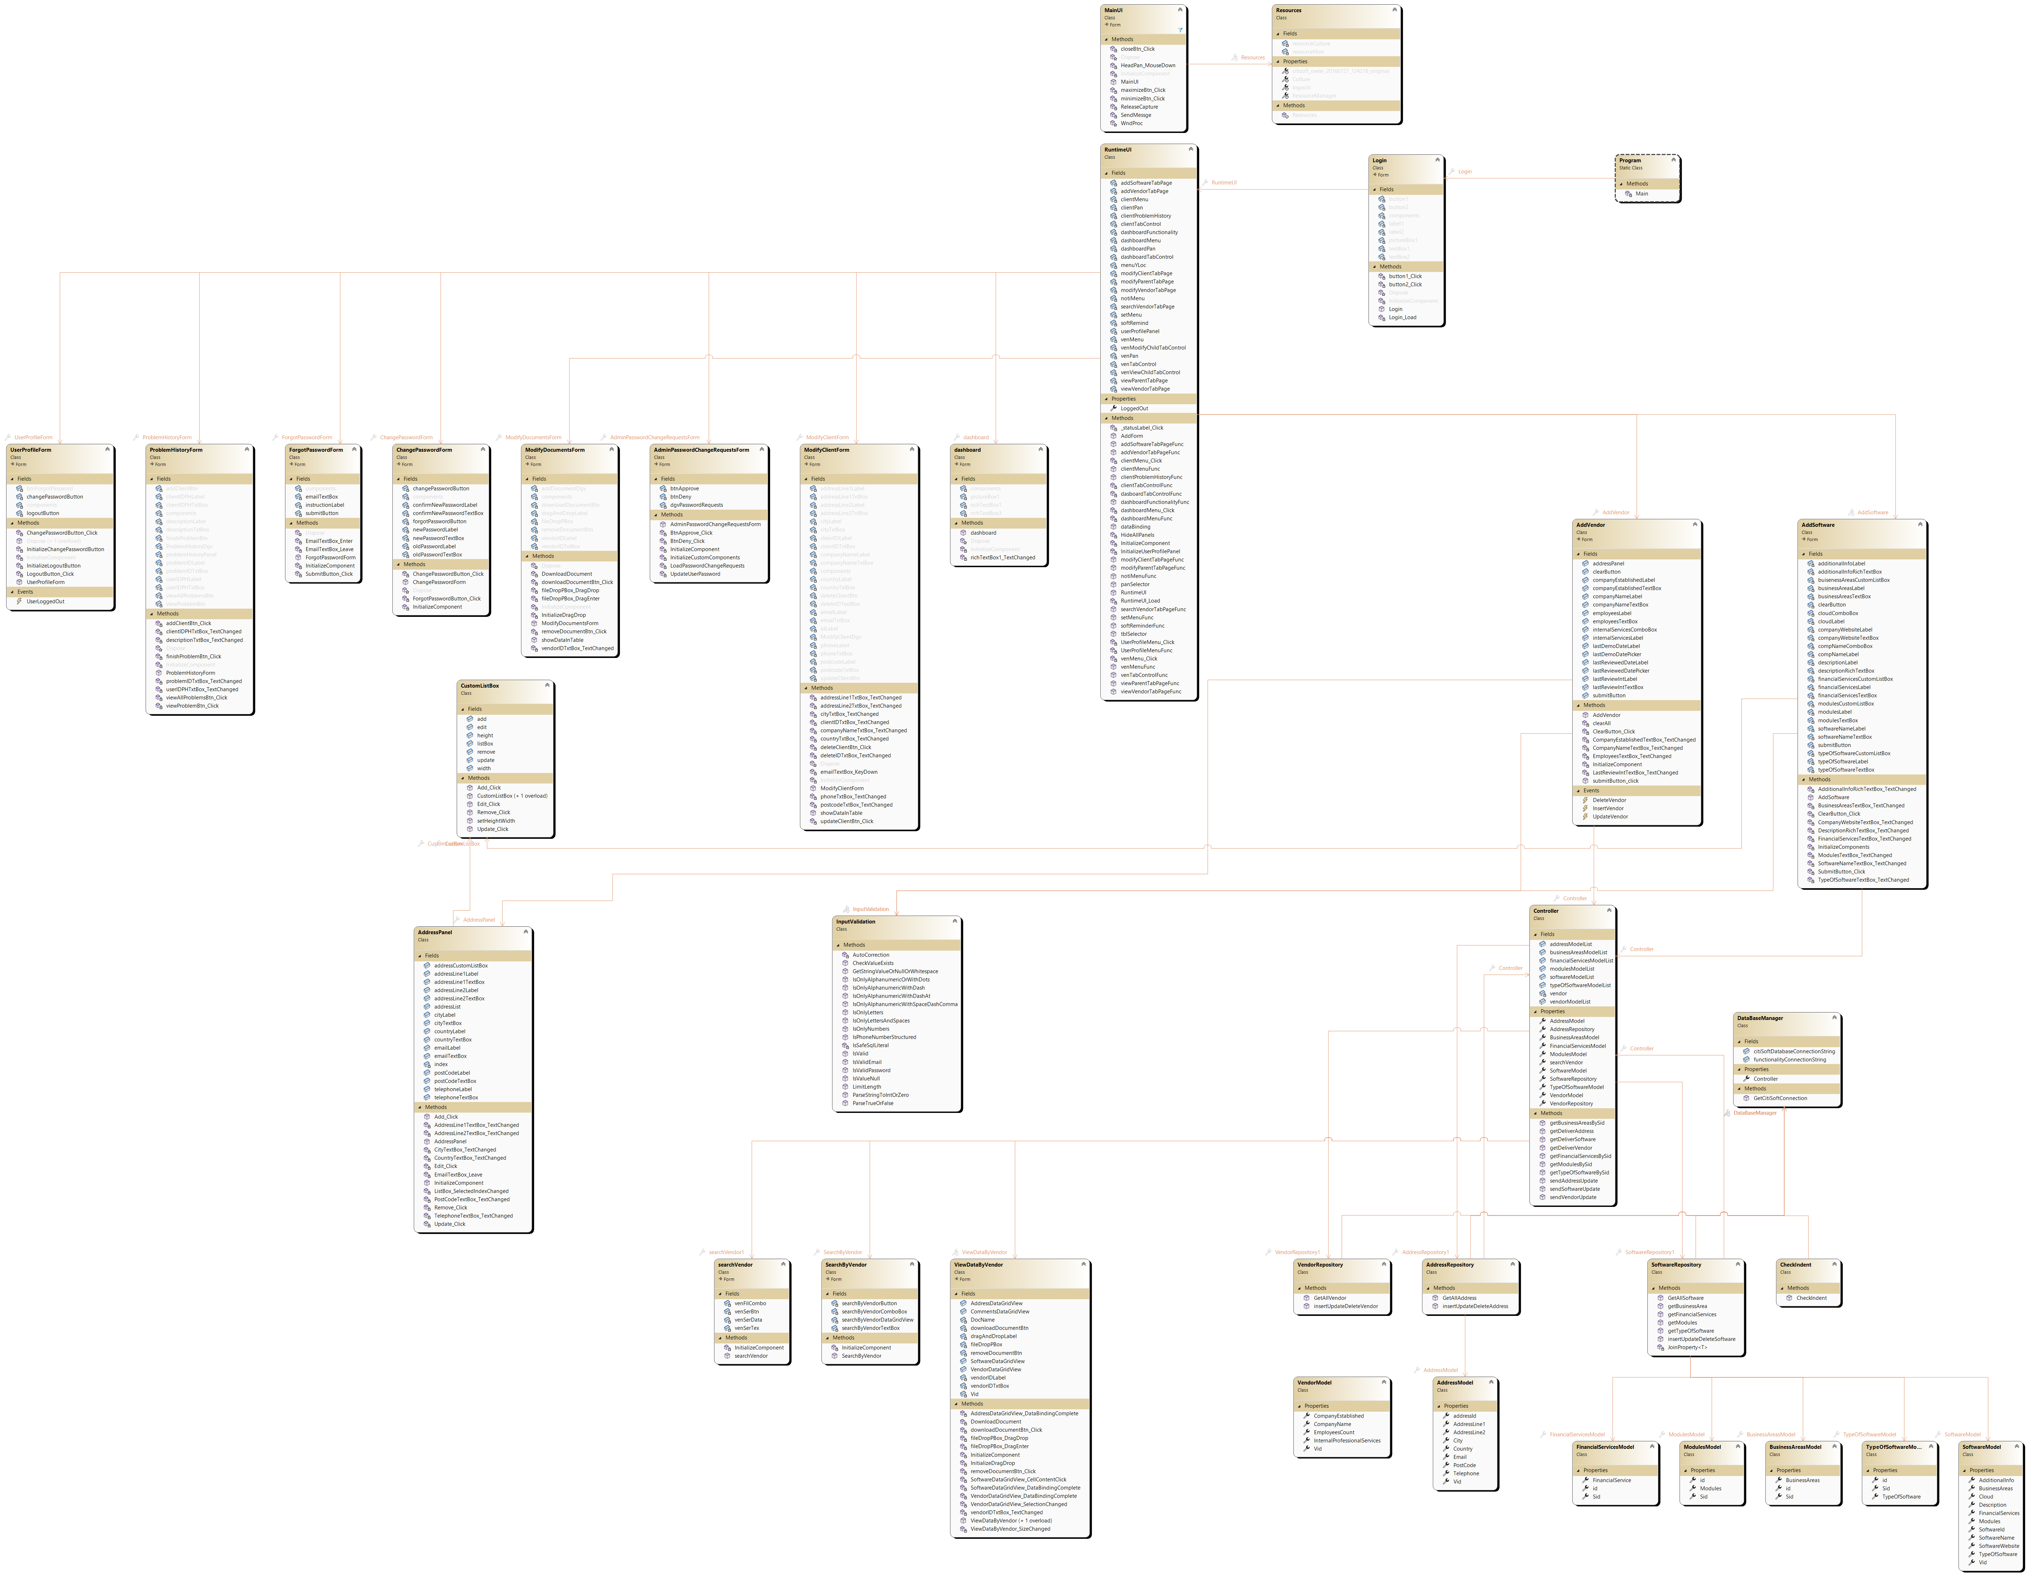

### 3.4.3 Sequence Diagrams

This sequence diagram briefly describes how the account management works. First, Admin selects Account Management, then Account Management System retrieves User Accounts, using Database. Database returns User Accounts, which are displayed. After that, there is a loop that performs add/update/remove operations, with confirmation in the end that is displayed as the operation status after that.

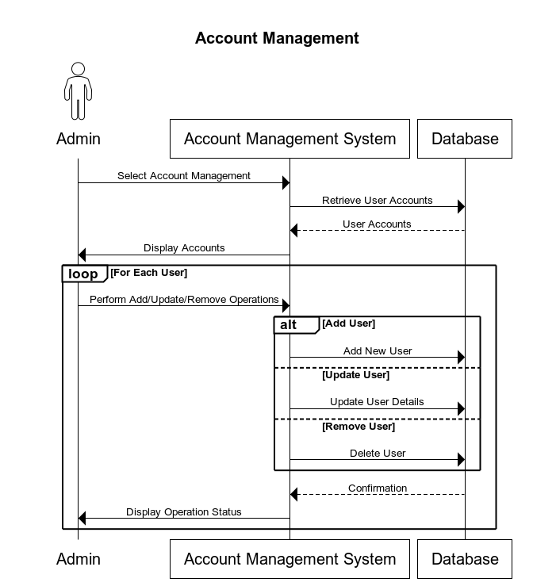

Shown sequence diagram describes how the Vendor Management process goes. At the start, Admin accesses Vendor Management, then requests Vendor Data from the Database, which returns data that is displayed after that. Second part is about Selecting add/remove/update vendor options, which results are displayed after being done.

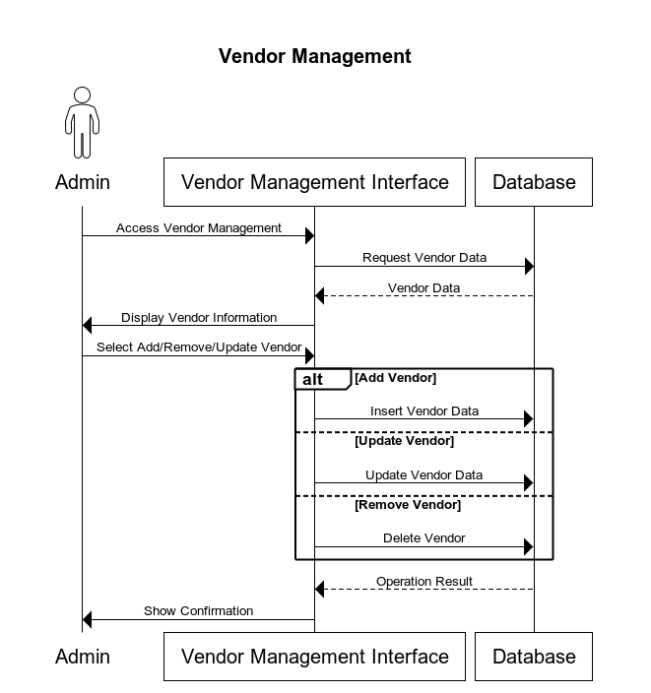

Provided sequence diagram briefly describes how the User Interaction with System works. First, User logs in, providing credentials that are strongly validated. After that the result of Granted or Denied is displayed. If user is logged in, he can access Dashboard/View Vendors/Search/Leave Reviews, which results are displayed after being processed.

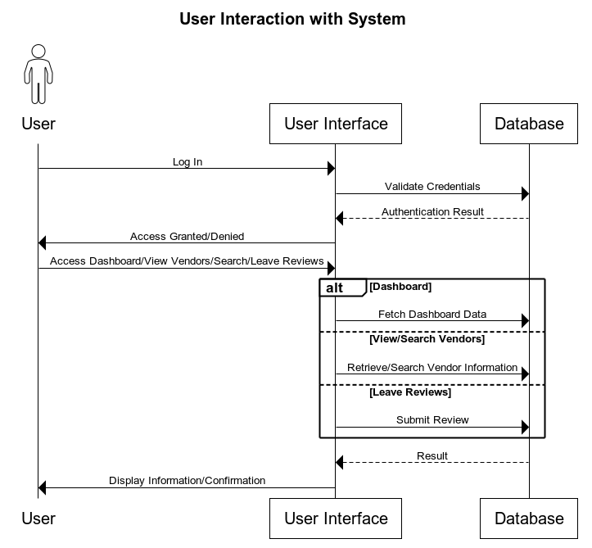

This sequence diagram describes how Request for Forgot Password goes. At the start, User selects Forgot Password option, requests email address, which is being validated and if user with this email exists, the password can be changed, if user does not exist, User will get a message that user with provided email not found.

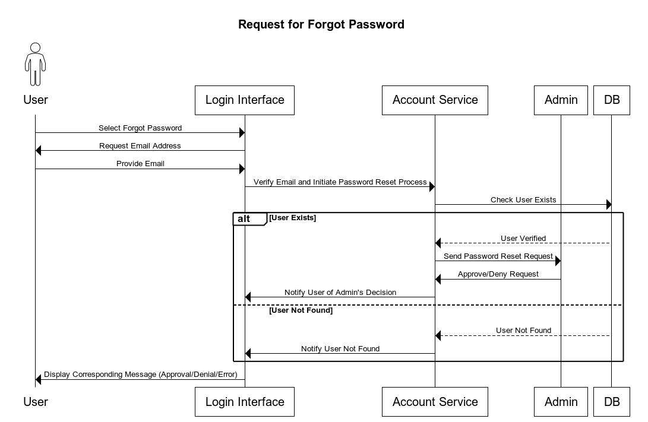

# Software Development Documentation

## 4.1 User story 1: As a (Admin, Manager) I can remove the client from the database

### 4.1.1 Design

#### 4.1.1.1 Sequence diagram

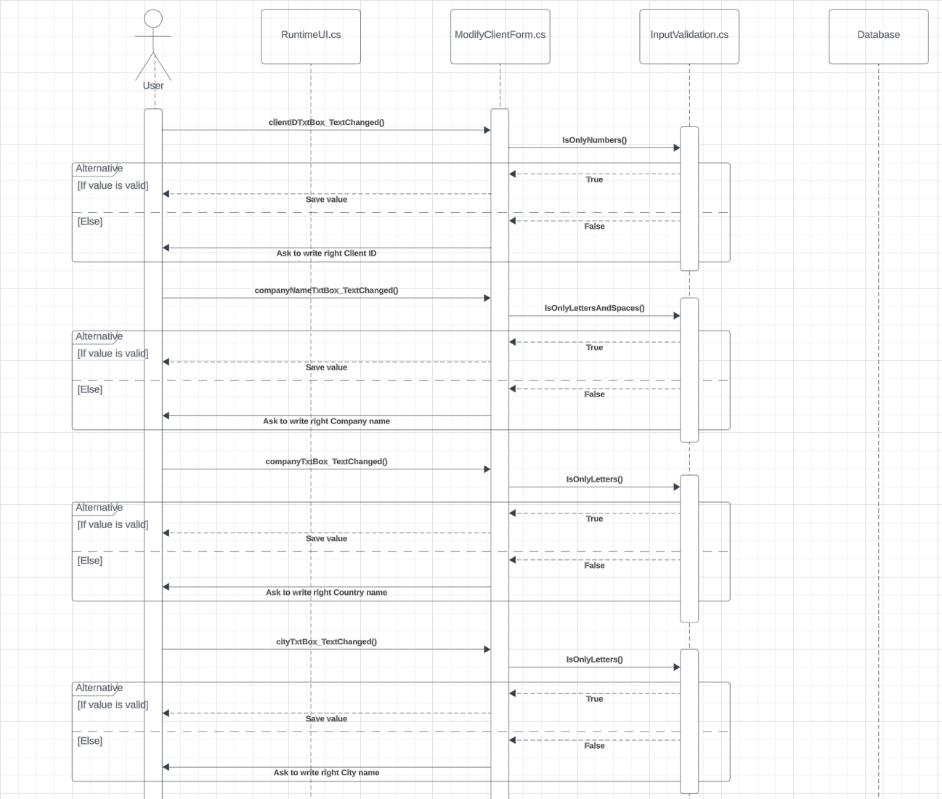

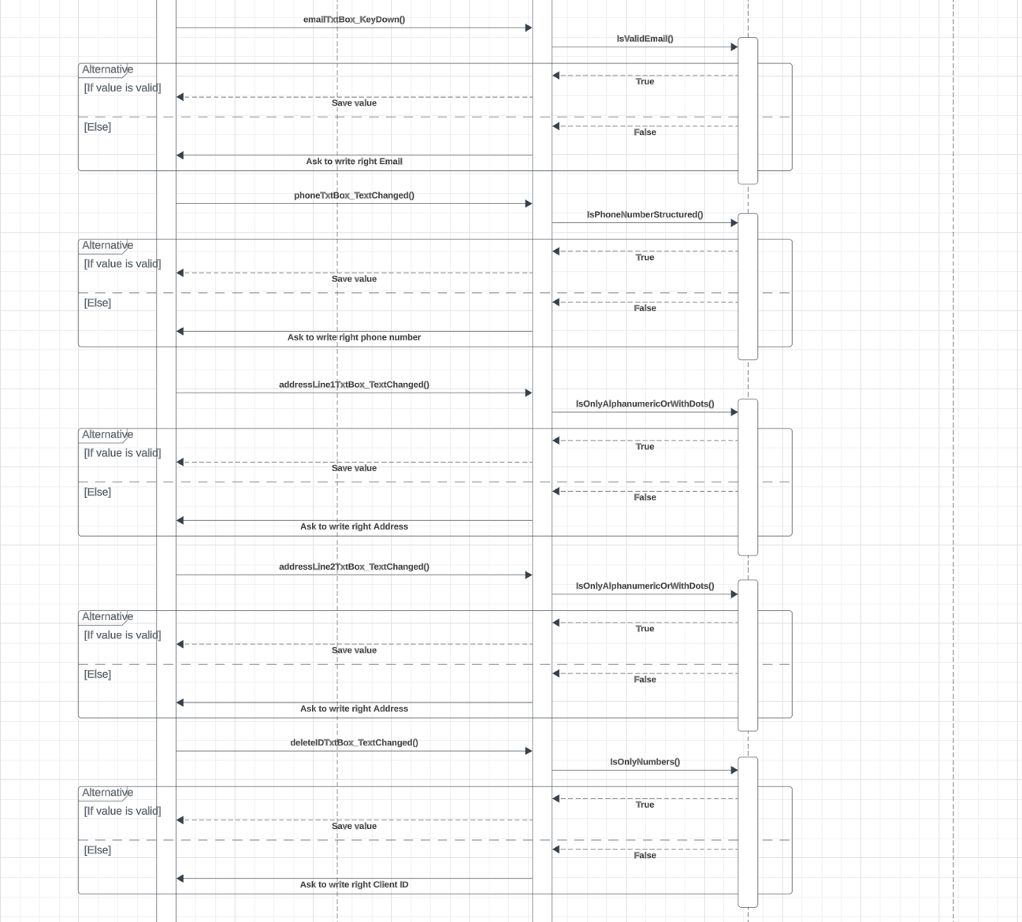

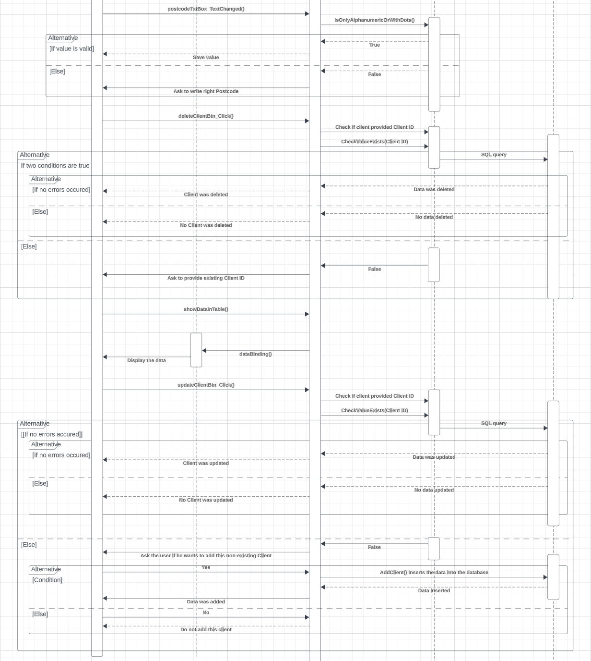

Provided sequence diagram contains validation for all input data before being used. Specifically, there is a class called "InputValidation.cs" that handles the validation process, for the entire application. Additionally, there is another class known as "RuntimeUI.cs" which serves as the main class. Furthermore, the diagram includes "ProblemHistoryForm.cs," which encompasses almost all control event handlers depicted in the UML diagram. It's evident that the diagram shows elements validations within each event handler. Once the validation processes are completed the program establishes a connection with the database. Sends a query to upload or delete data. Towards the end the "dataBinding() method, from "RuntimeUI.cs" is used to display all Client data.

#### 4.1.1.2 Class Diagram

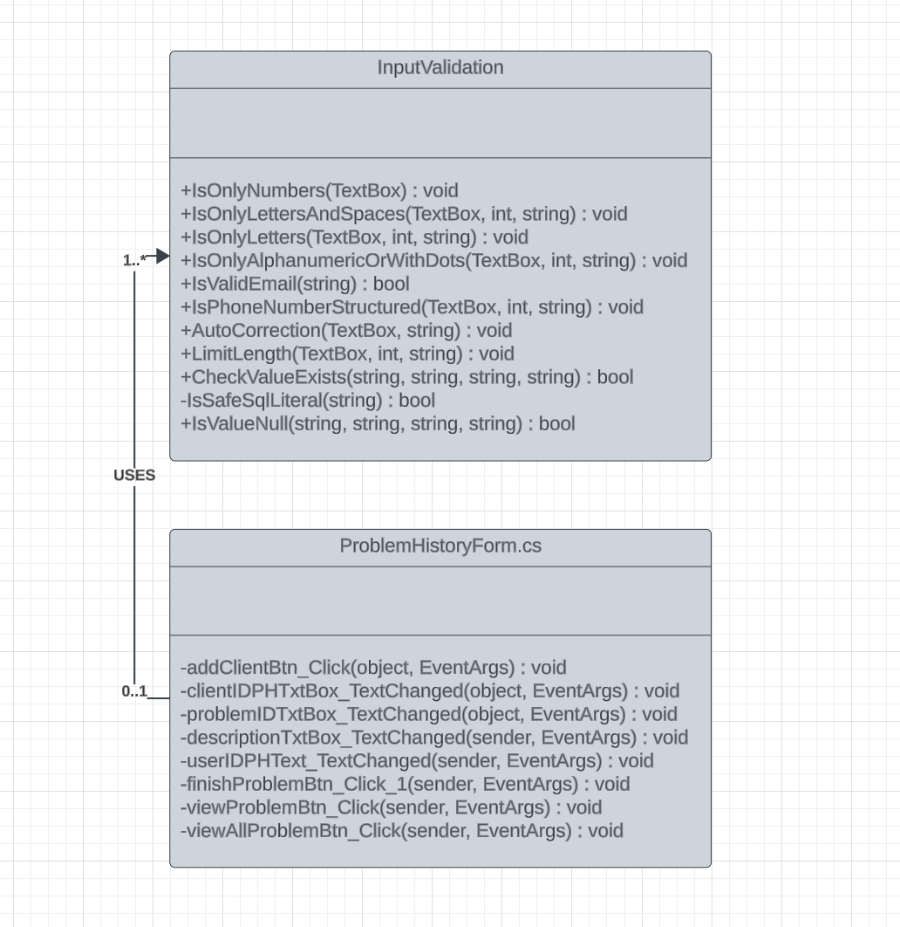

The Class diagram provided showcases the use of two classes to fulfill a user story. The first class, called "ProblemHistoryForm.cs " serves as a front end class, for displaying information and interacting with the user. The second class, "InputValidation.cs " plays a role in handling all data validation tasks before they are used. Additionally these classes have a "one to many" relationship meaning that "InputValidation.cs" is used multiple times, within the "ProblemHistoryForm.cs."

### 4.1.2 Implementation

DataBaseManager.cs class. Stores all constants used with database.

using System;

using System.Collections.Generic;

using System.Data.SqlClient;

using System.IO;

using System.Linq;

using System.Reflection;

using System.Text;

using System.Threading.Tasks;

namespace CitiSoft

{

// class that contains all commonly used constants and methods

partial class DataBaseManager

{

public static string functionalityConnectionString = "Data Source=(LocalDB)\\MSSQLLocalDB;AttachDbFilename=|DataDirectory|\\Functionality.mdf;Integrated Security=True;Connect Timeout=30";

public static string citiSoftDatabaseConnectionString = "Data Source=(LocalDB)\\MSSQLLocalDB;AttachDbFilename=|DataDirectory|\\CitiSoftDatabase.mdf;Integrated Security=True;";//Encrypt=False;Trust Server Certificate=False;Application Intent=ReadWrite;Multi Subnet Failover=False;";

public Controller Controller

{

get => default;

set

{

}

}

public static SqlConnection GetCitiSoftConnection()

{

return new SqlConnection(citiSoftDatabaseConnectionString);

}

public static SqlConnection GetFunctionalityConnection()

{

return new SqlConnection(functionalityConnectionString);

}

}

}

InputValidation.cs class. Methods of this class are used as a data validation methods. Comments are provided

using System;

using System.Collections.Generic;

using System.Data.SqlClient;

using System.Linq;

using System.Text;

using System.Text.RegularExpressions;

using System.Threading.Tasks;

using System.Windows.Forms;

namespace CitiSoft

{

internal class InputValidation

{

// checks if the input consists only from numbers

public static void IsOnlyNumbers(TextBox textBox)

{

if (textBox != null)

{

string input = textBox.Text;

foreach (char c in input)

{

if (!char.IsDigit(c)) // Allow numbers

{

// Show a message or handle the invalid character

MessageBox.Show("Only numbers are allowed.");

AutoCorrection(textBox, input);

break;

}

}

}

}

public static string GetStringValueOrNoneOrWhitespace(string input)

{

// If the input is not null, empty, or consists of only whitespace, return the input; otherwise, return null

return !string.IsNullOrWhiteSpace(input) ? input : "None";

}

public static int ParseStringToIntOrZero(string input)

{

// If the input is not null, attempt to parse it to an integer; otherwise, return 0

return !string.IsNullOrEmpty(input) && int.TryParse(input, out int result) ? result : 0;

}

public static bool ParseTrueOrFalse(String value)

{

return value == "Yes";

}

// checks if the input consists only from letters and spaces

public static void IsOnlyLettersAndSpaces(TextBox textBox, int length, string name)

{

if (textBox != null)

{

string input = textBox.Text;

// checks for length

if (textBox.Text.Length > length)

{

MessageBox.Show($"{name} name is too long");

AutoCorrection(textBox, input);

}

else

{

foreach (char c in input)

{

if (!char.IsLetter(c) && c != ' ') // Allow letters and spaces

{

// Show a message or handle the invalid character

MessageBox.Show("Only letters and spaces are allowed.");

AutoCorrection(textBox, input);

break;

}

}

}

}

}

// checks if the input consists only from letters

public static void IsOnlyLetters(TextBox textBox, int length, string name)

{

if (textBox != null)

{

string input = textBox.Text;

// checks for length

if (input.Length > length)

{

MessageBox.Show($"{name} name is too long");

AutoCorrection(textBox, input);

}

else

{

foreach (char c in input)

{

if (!char.IsLetter(c)) // Allow letters

{

// Show a message or handle the invalid character

MessageBox.Show("Only letters are allowed.");

AutoCorrection(textBox, input);

break;

}

}

}

}

}

public static void IsOnlyAlphanumericWithDashAt(TextBox textBox, int length, string name)

{

if (textBox != null)

{

string input = textBox.Text;

// checks for length

if (input.Length > length)

{

MessageBox.Show($"{name} address is too long");

AutoCorrection(textBox, input);

}

else

{

foreach (char c in input)

{

if (!char.IsLetterOrDigit(c) && c != ' ' && c != '-' && c != '@') // Allow letters, spaces, numbers, dash and at(@)

{

// Show a message or handle the invalid character

MessageBox.Show("Only letters, spaces, numbers, dash and at(@) are allowed.");

AutoCorrection(textBox, input);

break;

}

}

}

}

}

public static void IsOnlyAlphanumericWithDash(TextBox textBox, int length, string name)

{

if (textBox != null)

{

string input = textBox.Text;

// checks for length

if (input.Length > length)

{

MessageBox.Show($"{name} address is too long");

AutoCorrection(textBox, input);

}

else

{

foreach (char c in input)

{

if (!char.IsLetterOrDigit(c) && c != ' ' && c != '-') // Allow letters, spaces, numbers and dash

{

// Show a message or handle the invalid character

MessageBox.Show("Only letters, spaces, numbers and dash are allowed.");

AutoCorrection(textBox, input);

break;

}

}

}

}

}

// checks if the input consists only from alphanumerics or with dots

public static void IsOnlyAlphanumericOrWithDots(TextBox textBox, int length, string name)

{

if (textBox != null)

{

string input = textBox.Text;

// checks for length

if (input.Length > length)

{

MessageBox.Show($"{name} is too long");

AutoCorrection(textBox, input);

}

else

{

foreach (char c in input)

{

if (!char.IsLetterOrDigit(c) && c != ' ' && c != '.') // Allow letters, spaces, numbers and dots

{

// Show a message or handle the invalid character

MessageBox.Show("Only letters, spaces and numbers are allowed.");

AutoCorrection(textBox, input);

break;

}

}

}

}

}

public static void IsValid(TextBox textBox, int length, String message, String pattern = @"^[a-zA-Z\s]+$") // by default it will accept a-z,A-Z and spaces

{

if (textBox.Text.Length > 0)

{

string input = textBox.Text;

Regex regex = new Regex(pattern);

// checks for length

if (!regex.IsMatch(input))

{

MessageBox.Show( $"{message} are allowed.");

AutoCorrection(textBox, input);

}

else if (input.Length > length)

{

MessageBox.Show( "Too Long");

AutoCorrection(textBox, input);

}

}

}

public static void IsOnlyAlphanumericWithSpaceDashComma(TextBox textBox, int length, string name)

{

if (textBox != null)

{

string input = textBox.Text;

// checks for length

if (input.Length > length)

{

MessageBox.Show($"{name} address is too long");

AutoCorrection(textBox, input);

}

else

{

foreach (char c in input)

{

if (!char.IsLetterOrDigit(c) && c != ' ' && c != '.' && c != ',' && c != '-' ) // Allow letters, spaces, numbers,commas, dots and dash {

{ // Show a message or handle the invalid character

MessageBox.Show("Only letters, spaces, numbers,commas, dots and dash are allowed.");

AutoCorrection(textBox, input);

break;

}

}

}

}

}

// checks if the text is email structured

public static bool IsValidEmail(string email)

{

if (string.IsNullOrWhiteSpace(email))

return false;

try

{

// Normalize the domain

email = Regex.Replace(email, @"(@)(.+)$", DomainMapper, RegexOptions.None, TimeSpan.FromMilliseconds(200));

// Examines the domain part of the email and normalizes it.

string DomainMapper(Match match)

{

var idn = new System.Globalization.IdnMapping();

string domainName = idn.GetAscii(match.Groups[2].Value);

return match.Groups[1].Value + domainName;

}

return Regex.IsMatch(email,

@"^[^@\s]+@[^@\s]+\.[^@\s]+$",

RegexOptions.IgnoreCase, TimeSpan.FromMilliseconds(250));

}

catch (RegexMatchTimeoutException)

{

return false;

}

catch (ArgumentException)

{

return false;

}

}

// checks if the input consists only from numbers, spaces and '+'

public static void IsPhoneNumberStructured(TextBox textBox, int length, string name)

{

if (textBox != null)

{

string input = textBox.Text;

// checks for length

if (input.Length > length)

{

MessageBox.Show($"{name} is too long");

AutoCorrection(textBox, input);

}

else

{

foreach (char c in input)

{

if (!char.IsDigit(c) && c != ' ' && c != '+') // Allow letters spaces and numbers

{

// Show a message or handle the invalid character

MessageBox.Show("Please don't inlcude any letters.");

AutoCorrection(textBox, input);

break;

}

}

}

}

}

private static void AutoCorrection(TextBox textBox, string input)

{

// Remove the last character

if (textBox.Text.Length >0)

{

textBox.Text = input.Substring(0, input.Length - 1);

// Set the cursor position to the end of the text

textBox.SelectionStart = textBox.Text.Length;

textBox.SelectionLength = 0;

}

}

// checks if the input holds a specific length

public static void LimitLength(TextBox textBox, int length, string name)

{

if (textBox != null)

{

string input = textBox.Text;

// checks for length

if (input.Length > length)

{

MessageBox.Show($"{name} is too long, should be less than {length} characters");

AutoCorrection(textBox, input);

}

}

}

// the following two functions were generated by ChatGPT 4 and adapted by author, http://chat.openai.com

public static bool CheckValueExists(string connectionString, string tableName, string columnName, string value)

{

// Sanitize the input for table and column names to prevent SQL injection

// This is a rudimentary check; you should ideally check against known good values or use metadata

if (!IsSafeSqlLiteral(tableName) || !IsSafeSqlLiteral(columnName))

{

throw new ArgumentException("Invalid table or column name.");

}

// Construct the SQL query

string query = $"SELECT COUNT(1) FROM [{tableName}] WHERE [{columnName}] = @value";

using (SqlConnection connection = new SqlConnection(connectionString))

{

using (SqlCommand command = new SqlCommand(query, connection))

{

// Use a parameter for the value to protect against SQL injection

command.Parameters.AddWithValue("@value", value);

try

{

connection.Open();

int exists = (int)command.ExecuteScalar();

return exists > 0;

}

catch (SqlException)

{

// Handle exceptions as appropriate for your application

MessageBox.Show("An error occurred accessing the database");

return false;

}

}

}

}

// Helper method to check if the table or column name is a safe SQL literal

// This method should be tailored to meet the security requirements of your application

private static bool IsSafeSqlLiteral(string input)

{

// Perform checks against known good values, patterns, or metadata

// For the sake of this example, we only allow alphanumeric characters and underscores

return Regex.IsMatch(input, @"^\w+$");

}

// checks if the value is NULL

public static bool IsValueNull(string connectionString, string tableName, string columnName, string idValue)

{

bool isNull = false; // Default assumption is that the value is not NULL

using (SqlConnection connection = new SqlConnection(connectionString))

{

connection.Open();

SqlTransaction transaction = connection.BeginTransaction();

try

{

using (SqlCommand command = new SqlCommand($"SELECT {columnName} FROM {tableName} WHERE vid = @VendorID;", connection, transaction))

{

// uses parameterizing to prevent SQL injections

command.Parameters.AddWithValue("@VendorID", idValue);

object result = command.ExecuteScalar();

// Check if the result is DBNull or null

if (result == DBNull.Value || result == null)

{

isNull = true;

}

}

transaction.Commit();

}

catch (SqlException ex)

{

transaction.Rollback();

MessageBox.Show($"An error occurred: {ex.Message}");

}

}

return isNull;

}

public static bool IsValidPassword(string password)

{

if (string.IsNullOrWhiteSpace(password))

{

MessageBox.Show("Password cannot be empty.");

return false;

}

if (password.Length < 8)

{

MessageBox.Show("Password must be at least 8 characters long.");

return false;

}

if (!Regex.IsMatch(password, @"[A-Z]"))

{

MessageBox.Show("Password must contain at least one uppercase letter.");

return false;

}

if (!Regex.IsMatch(password, @"[a-z]"))

{

MessageBox.Show("Password must contain at least one lowercase letter.");

return false;

}

if (!Regex.IsMatch(password, @"[0-9]"))

{

MessageBox.Show("Password must contain at least one digit.");

return false;

}

if (!Regex.IsMatch(password, @"[\W_]"))

{

MessageBox.Show("Password must contain at least one special character.");

return false;

}

return true;

}

}

}

ModifyClientForm.cs. This form is used to modify the client, in particular: update and delete.

Comments are included.

using System;

using System.Collections.Generic;

using System.ComponentModel;

using System.Data;

using System.Data.SqlClient;

using System.Drawing;

using System.Linq;

using System.Text;

using System.Text.RegularExpressions;

using System.Threading.Tasks;

using System.Windows.Forms;

namespace CitiSoft

{

public partial class ModifyClientForm : Form

{

public ModifyClientForm()

{

InitializeComponent();

}

private void updateClientBtn_Click(object sender, EventArgs e)

{

// checks if the user provided Client ID

if(clientIDTxtBox.Text == "")

{

MessageBox.Show("Please provide client id");

return;

}

// checks if the user provided wrong Client ID

if(!InputValidation.CheckValueExists(DataBaseManager.functionalityConnectionString, "Client", "cid", clientIDTxtBox.Text))

{

DialogResult result = MessageBox.Show("Client ID you have provided does not exist. Do you want to add this client?", "Client Not Found", MessageBoxButtons.YesNo);

if (result == DialogResult.Yes)

{

// Call a method to add the client

if(clientIDTxtBox.Text == "" || countryTxtBox.Text == "" || companyNameTxtBox.Text == "" || cityTxtBox.Text == "" || postcodeTxtBox.Text == "" || phoneTxtBox.Text == "" || addressLine1TxtBox.Text == "" || addressLine2TxtBox.Text == "" || emailTxtBox.Text == "")

{

MessageBox.Show("Please provide all data first");

return;

}

AddClient();

}

return;

}

using (SqlConnection connection = new SqlConnection(DataBaseManager.functionalityConnectionString))

{

connection.Open();

SqlTransaction transaction = connection.BeginTransaction();

try

{

// Start building the SQL command based on provided input

List<string> clientUpdates = new List<string>();

List<string> addressUpdates = new List<string>();

if (!string.IsNullOrWhiteSpace(companyNameTxtBox.Text))

clientUpdates.Add("compName = @CompName");

if (!string.IsNullOrWhiteSpace(phoneTxtBox.Text))

addressUpdates.Add("phone = @Phone");

if (!string.IsNullOrWhiteSpace(emailTxtBox.Text))

addressUpdates.Add("email = @Email");

if (!string.IsNullOrWhiteSpace(addressLine1TxtBox.Text))

addressUpdates.Add("AddressLine1 = @addressLine1");

if (!string.IsNullOrWhiteSpace(addressLine2TxtBox.Text))

addressUpdates.Add("AddressLine2 = @addressLine2");

if (!string.IsNullOrWhiteSpace(cityTxtBox.Text))

addressUpdates.Add("City = @City");

if (!string.IsNullOrWhiteSpace(countryTxtBox.Text))

addressUpdates.Add("Country = @Country");

if(!string.IsNullOrWhiteSpace(postcodeTxtBox.Text))

addressUpdates.Add("PostCode = @Postcode");

// checks if any data was provided

if (clientUpdates.Count == 0 && addressUpdates.Count == 0)

{

MessageBox.Show("No data provided to update.");

return;

}

string updateSql = "";

if (clientUpdates.Count > 0)

updateSql += "UPDATE Client SET " + string.Join(", ", clientUpdates) + " WHERE cid = @ClientID; ";

if (addressUpdates.Count > 0)

updateSql += "UPDATE CustAddress SET " + string.Join(", ", addressUpdates) + " WHERE cid = @ClientID;";

using (SqlCommand command = new SqlCommand(updateSql, connection, transaction))

{

command.Parameters.AddWithValue("@ClientID", clientIDTxtBox.Text);

if (!string.IsNullOrWhiteSpace(companyNameTxtBox.Text))

command.Parameters.AddWithValue("@CompName", companyNameTxtBox.Text);

if (!string.IsNullOrWhiteSpace(phoneTxtBox.Text))

command.Parameters.AddWithValue("@Phone", phoneTxtBox.Text);

if (!string.IsNullOrWhiteSpace(emailTxtBox.Text))

command.Parameters.AddWithValue("@Email", emailTxtBox.Text);

if(!string.IsNullOrWhiteSpace(addressLine1TxtBox.Text))

command.Parameters.AddWithValue("@AddressLine1", addressLine1TxtBox.Text);

if (!string.IsNullOrWhiteSpace(addressLine2TxtBox.Text))

command.Parameters.AddWithValue("@AddressLine2", addressLine2TxtBox.Text);

if (!string.IsNullOrWhiteSpace(cityTxtBox.Text))

command.Parameters.AddWithValue("@City", cityTxtBox.Text);

if (!string.IsNullOrWhiteSpace(countryTxtBox.Text))

command.Parameters.AddWithValue("@Country", countryTxtBox.Text);

if (!string.IsNullOrWhiteSpace(postcodeTxtBox.Text))

command.Parameters.AddWithValue("@Postcode", postcodeTxtBox.Text);

int rowsAffected = command.ExecuteNonQuery();

if (rowsAffected > 0)

{

MessageBox.Show("Update successful.");

transaction.Commit(); // Only commit if no errors occurred

}

else

{

MessageBox.Show("No rows Updated. It's possible that the client did not exist.");

transaction.Rollback(); // Rollback if no rows affected

}

}

}

catch (SqlException)

{

transaction.Rollback(); // Rollback on error

MessageBox.Show("An error occurred while updating the client");

}

}

}

// adds the client to the database

private void AddClient()

{

using (SqlConnection connection = new SqlConnection(DataBaseManager.functionalityConnectionString))

{

connection.Open();

SqlTransaction transaction = connection.BeginTransaction();

try

{

// using SCOPE_IDENTITY() to retrieve last pk id from Client table

string insertSql = "INSERT INTO Client (compName) VALUES (@CompName); " +

"INSERT INTO CustAddress (cid, phone, email, addressLine1, addressLine2, city, country, postCode) " +

"VALUES (SCOPE_IDENTITY(), @Phone, @Email, @AddressLine1, @AddressLine2, @City, @Country, @Postcode);";

using (SqlCommand command = new SqlCommand(insertSql, connection, transaction))

{

if(!string.IsNullOrWhiteSpace(companyNameTxtBox.Text))

command.Parameters.AddWithValue("@CompName", companyNameTxtBox.Text);

if(!string.IsNullOrWhiteSpace(phoneTxtBox.Text))

command.Parameters.AddWithValue("@Phone", phoneTxtBox.Text);

if(!string.IsNullOrWhiteSpace(emailTxtBox.Text))

command.Parameters.AddWithValue("@Email", emailTxtBox.Text);

if(!string.IsNullOrWhiteSpace(addressLine1TxtBox.Text))

command.Parameters.AddWithValue("@AddressLine1", addressLine1TxtBox.Text);

if(!string.IsNullOrWhiteSpace(addressLine2TxtBox.Text))

command.Parameters.AddWithValue("@AddressLine2", addressLine2TxtBox.Text);

if(!string.IsNullOrWhiteSpace(cityTxtBox.Text))

command.Parameters.AddWithValue("@City", cityTxtBox.Text);

if(!string.IsNullOrWhiteSpace(countryTxtBox.Text))

command.Parameters.AddWithValue("@Country", countryTxtBox.Text);

if(!string.IsNullOrWhiteSpace(postcodeTxtBox.Text))

command.Parameters.AddWithValue("@Postcode", postcodeTxtBox.Text);

// ExecuteNonQuery is used for INSERT, UPDATE, DELETE operations

int rowsAffected = command.ExecuteNonQuery();

if(rowsAffected > 0)

{

// Retrieve the last inserted ID

string selectLastIdSql = "SELECT SCOPE_IDENTITY();";

command.CommandText = selectLastIdSql;

object result = command.ExecuteScalar();

if(result != null)

{

MessageBox.Show("Insertion successful.");

}

else

{

MessageBox.Show("No rows inserted. Failed to retrieve the last inserted ID.");

}

transaction.Commit(); // Only commit if no errors occurred

}

else

{

MessageBox.Show("No rows inserted. Failed to add the client.");

transaction.Rollback(); // Rollback if no rows affected

}

}

}

catch (SqlException)

{

transaction.Rollback(); // Rollback on error

MessageBox.Show("An error occurred while adding the client");

}

}

}

private void deleteClientBtn_Click(object sender, EventArgs e)

{

// checks if the user provided Client ID

if(deleteIDTextBox.Text == "")

{

MessageBox.Show("Please provide client ID");

return;

}

// checks if the user provided wrong ID

if (!InputValidation.CheckValueExists(DataBaseManager.functionalityConnectionString, "Client", "cid", deleteIDTextBox.Text))

{

MessageBox.Show("Client ID you have provided does not exist");

deleteIDTextBox.Text = string.Empty;

return;

}

using (SqlConnection connection = new SqlConnection(DataBaseManager.functionalityConnectionString))

{

connection.Open();

SqlTransaction transaction = connection.BeginTransaction();

try

{

using (SqlCommand command = new SqlCommand("DELETE FROM CustAddress WHERE cid = @ClientID DELETE FROM Client WHERE cid = @ClientID;", connection, transaction))

{

// uses parameterizing to prevent from SQL injections

command.Parameters.AddWithValue("@ClientID", deleteIDTextBox.Text);

int rowsAffected = command.ExecuteNonQuery();

if (rowsAffected > 0)

{

MessageBox.Show("Delete successful.");

transaction.Commit(); // Only commit if no errors occurred

deleteIDTextBox.Text = "";

}

else

{

MessageBox.Show("No rows deleted. It's possible that the client did not exist.");

transaction.Rollback(); // Rollback if no rows affected

deleteIDTextBox.Text = "";

}

}

}

catch (SqlException)

{

transaction.Rollback(); // Rollback on error

MessageBox.Show("An error occurred while deleting the client");

}

}

}

private void clientIDTxtBox_TextChanged(object sender, EventArgs e)

{

TextBox textBox = sender as TextBox;

InputValidation.IsOnlyNumbers(textBox);

}

private void companyNameTxtBox_TextChanged(object sender, EventArgs e)

{

TextBox textBox = sender as TextBox;

InputValidation.IsOnlyLettersAndSpaces(textBox, 30, "Company");

}

private void countryTxtBox_TextChanged(object sender, EventArgs e)

{

TextBox textBox = sender as TextBox;

InputValidation.IsOnlyLetters(textBox, 30, "Country");

}

private void cityTxtBox_TextChanged(object sender, EventArgs e)

{

TextBox textBox = sender as TextBox;

InputValidation.IsOnlyLetters(textBox, 30, "City");

}

// checks only after the enter key was pressed

private void emailTextBox_KeyDown(object sender, KeyEventArgs e)

{

if (e.KeyCode == Keys.Enter)

{

TextBox textBox = sender as TextBox;

// checks for length

if (textBox.Text.Length > 30)

{

MessageBox.Show("Email is too long.");

}

if (textBox != null && !InputValidation.IsValidEmail(textBox.Text))

{

MessageBox.Show("Invalid email format.");

}

}

}

private void phoneTxtBox_TextChanged(object sender, EventArgs e)

{

TextBox textBox = sender as TextBox;

InputValidation.IsPhoneNumberStructured(textBox, 15, "Phone number");

}

private void addressLine1TxtBox_TextChanged(object sender, EventArgs e)

{

TextBox textBox = sender as TextBox;

InputValidation.IsOnlyAlphanumericOrWithDots(textBox, 30, "Address Line 1");

}

private void addressLine2TxtBox_TextChanged(object sender, EventArgs e)

{

TextBox textBox = sender as TextBox;

InputValidation.IsOnlyAlphanumericOrWithDots(textBox, 30, "Address Line 2");

}

private void deleteIDTxtBox_TextChanged(object sender, EventArgs e)

{

TextBox textBox = sender as TextBox;

InputValidation.IsOnlyNumbers(textBox);

}

private void postcodeTxtBox_TextChanged(object sender, EventArgs e)

{

TextBox textBox = sender as TextBox;

InputValidation.IsOnlyAlphanumericOrWithDots(textBox, 30, "Postcode");

}

// inserts data from the database into the data grid view

public void showDataInTable()

{

RuntimeUI.dataBinding(DataBaseManager.functionalityConnectionString, "SELECT c.cid AS 'Client ID', c.compName AS 'Company Name', cu.phone AS 'Phone', cu.email AS 'Email', CONCAT(cu.addressLine1, ' ', cu.addressLine2) AS 'Address', cu.city AS 'City', cu.country AS 'Country', cu.postCode AS 'Postcode' FROM Client c JOIN CustAddress cu ON c.cid = cu.cid; ", ModifyClientDgv);

}

}

}

## 4.2 User story 2: As a (Admin, Manager, User) I can view and add the client to the Problem History

### 4.2.1 Design

#### 4.2.1.1 Sequence diagram

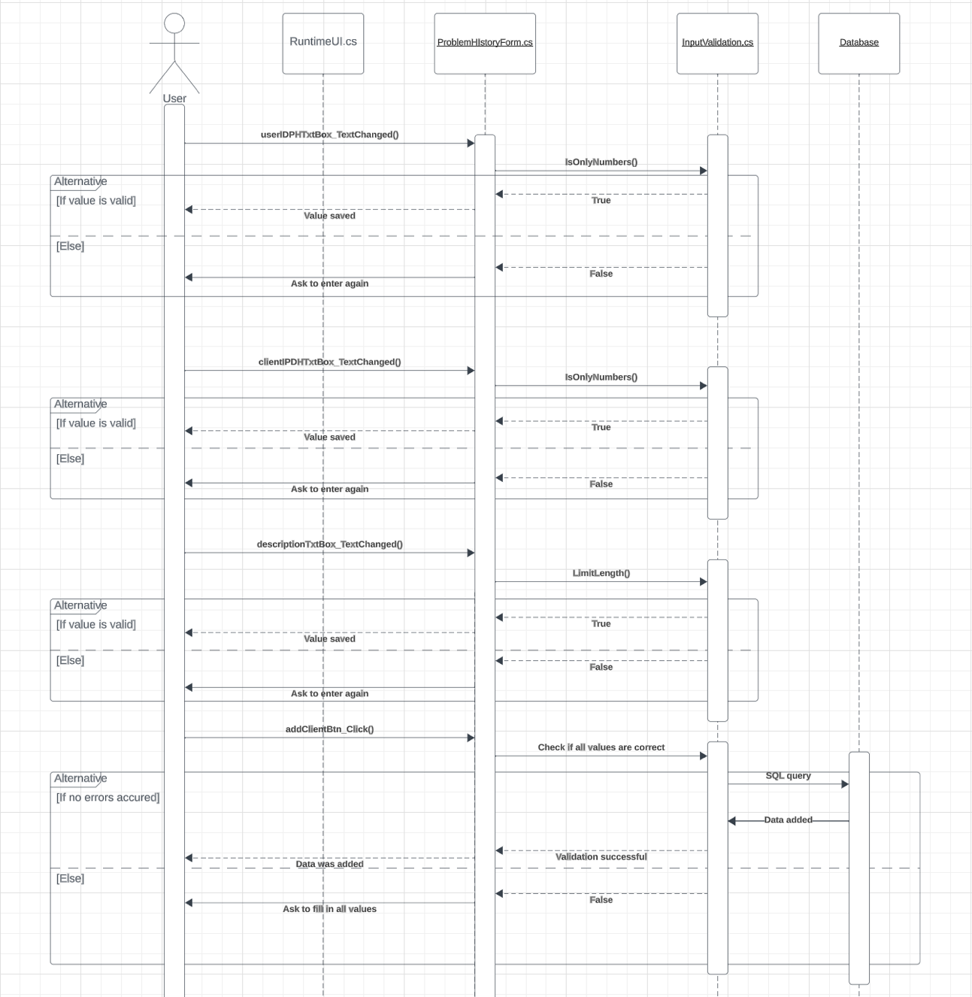

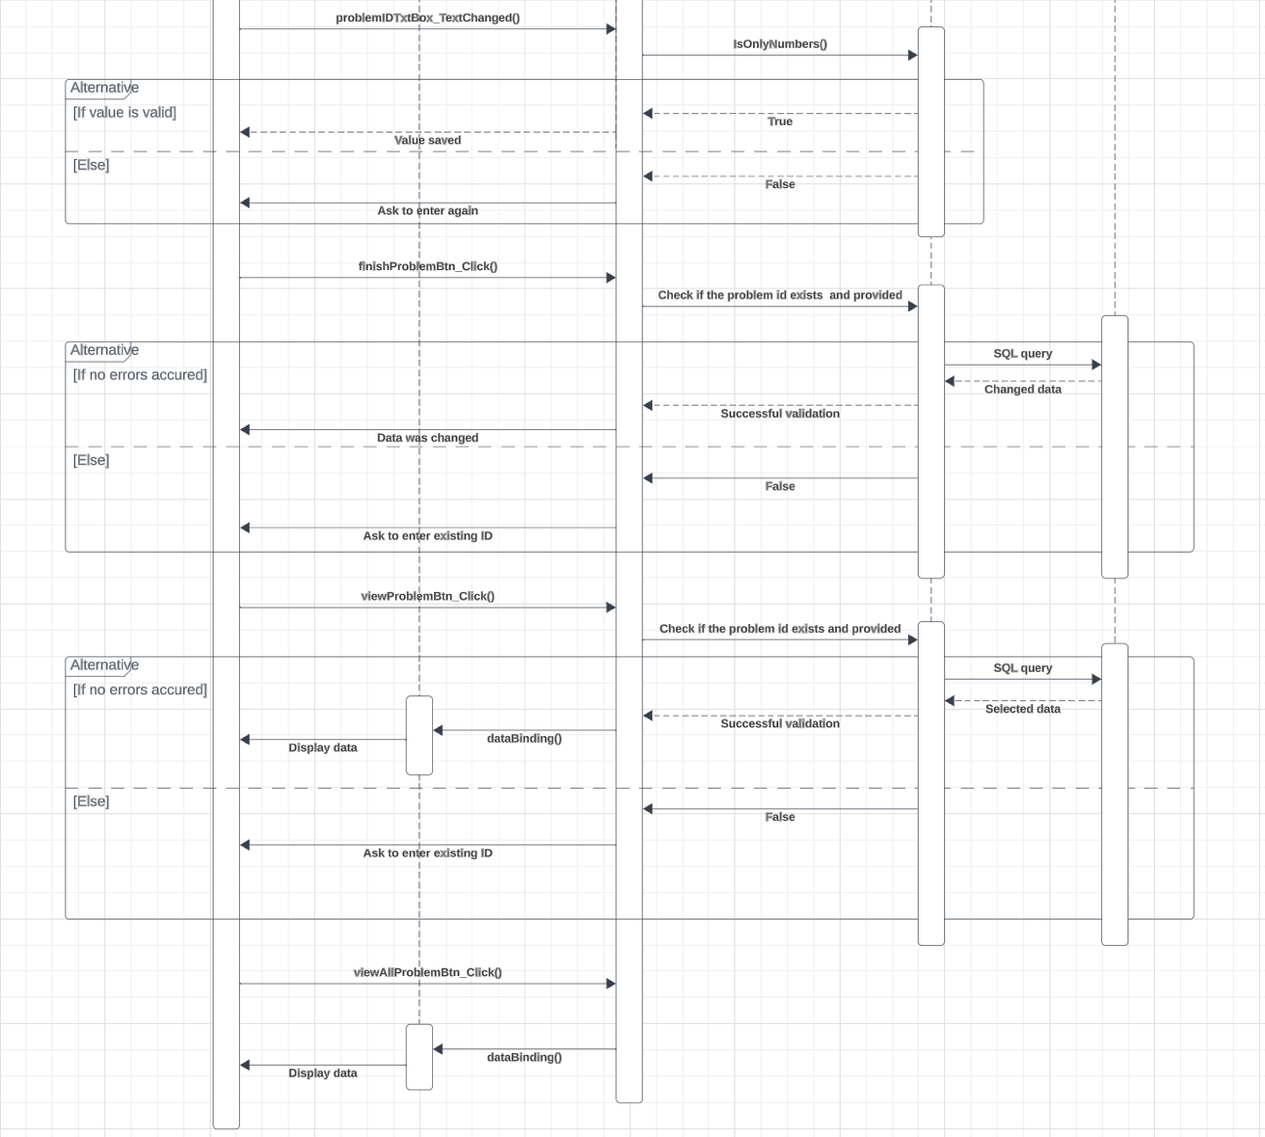

Having look at the shown sequence diagram it is clear that all input data is processed by strong validation before used. Also, there is a special class called: “InputValidation.cs”, which was created specifically to handle all validation for whole application. There also other class called “RuntimeUI.cs”, which is main class. Moreover, “ProblemHistoryForm.cs” is provided that contains all controls’s event handlers. There event handlers are shown in this UML diagram. It is seen that diagram contains repetitive parts, which are validations in each event handler. After validation is completed, program is connected with database and sends a query to get or change data. In the end, “viewAllProblemBtn_Click()” method is used to call RuntimeUI.cs “databinding()” method that displays all data that needed to observe problem history.

#### 4.2.1.2 Class Diagram

#### 

In the provided Class diagram, it is seen that only two classes are used for one user story. One class called “ModifyClientForm.cs” is used as a front end class, which shows whole information and interacts with user, And second class: “InputValidation.cs”, which is needed to handle all validation of data before using it. Moreover, the relation between these classes is “one-to-many”, which means that “InputValidaton.cs ” is used many times in “ModifyClientForm.cs”.

### 4.2.2 Implementation

ProblemHistoryForm.cs. This form is used to add client to the problem history, review a specific problem, or finish the problem. Comments are provided

using System;

using System.Collections.Generic;

using System.ComponentModel;

using System.Data;

using System.Data.SqlClient;

using System.Drawing;

using System.Linq;

using System.Runtime.Remoting.Contexts;

using System.Text;

using System.Threading.Tasks;

using System.Windows.Forms;

namespace CitiSoft

{

public partial class ProblemHistoryForm : Form

{

public ProblemHistoryForm()

{

InitializeComponent();

}

// adds the client to the ProblemHistory table

private void addClientBtn_Click(object sender, EventArgs e)

{

// checks if the user did not put text in any textboxes

if (clientIDPHTxtBox.Text == "" || descriptionTxtBox.Text == "" || userIDPHTxtBox.Text == "")

{

MessageBox.Show("Please fill in all text boxes");

return;

}

// checks if the user provided wrong Client ID

if (!InputValidation.CheckValueExists(DataBaseManager.functionalityConnectionString, "Client", "cid", clientIDPHTxtBox.Text))

{

MessageBox.Show("Client ID you have provided does not exist");

clientIDPHTxtBox.Text = string.Empty;

return;

}

// checks if the user provided wrong User ID

if (!InputValidation.CheckValueExists(DataBaseManager.functionalityConnectionString, "User", "uid", userIDPHTxtBox.Text))

{

MessageBox.Show("Your ID does not exist");

userIDPHTxtBox.Text = string.Empty;

return;

}

using (SqlConnection connection = new SqlConnection(DataBaseManager.functionalityConnectionString))

{

connection.Open();

SqlTransaction transaction = connection.BeginTransaction();

try

{

using (SqlCommand command = new SqlCommand("INSERT INTO ProblemHistory (cid, uid, [date], [desc], isClosed, lstRevDate) VALUES (@ClientID, @UserID, @Date, @Description, @IsClosed, @LstRevDate);", connection, transaction))

{

// uses parameterizing to prevent from SQL injections

command.Parameters.AddWithValue("@ClientID", clientIDPHTxtBox.Text);

command.Parameters.AddWithValue("@UserID", userIDPHTxtBox.Text);

command.Parameters.AddWithValue("@Description", descriptionTxtBox.Text);

command.Parameters.AddWithValue("@Date", DateTime.Today.ToString("yyyy-MM-dd"));

command.Parameters.AddWithValue("@LstRevDate", DateTime.Today.ToString("yyyy-MM-dd"));

command.Parameters.AddWithValue("@IsClosed", 0);

// checks if any rows were added

int rowsAffected = command.ExecuteNonQuery();

if (rowsAffected > 0)

{

MessageBox.Show("Problem Added.");

transaction.Commit(); // Only commit if no errors occurred

descriptionLabel.Text = string.Empty;

clientIDPHTxtBox.Text = string.Empty;

userIDPHTxtBox.Text = string.Empty;

}

else

{

MessageBox.Show("Nothing was added. Probably you have provided wrong IDs.");

transaction.Rollback(); // Rollback if no rows affected

clientIDPHTxtBox.Text = string.Empty;

userIDPHTxtBox.Text = string.Empty;

}

}

}

catch (SqlException)

{

transaction.Rollback(); // Rollback on error

MessageBox.Show("An error occurred while adding the problem");

clientIDPHTxtBox.Text = string.Empty;

userIDPHTxtBox.Text = string.Empty;

}

}

}

private void clientIDPHTxtBox_TextChanged(object sender, EventArgs e)

{

TextBox textBox = sender as TextBox;

InputValidation.IsOnlyNumbers(textBox);

}

private void problemIDTxtBox_TextChanged(object sender, EventArgs e)

{

TextBox textBox = sender as TextBox;

InputValidation.IsOnlyNumbers(textBox);

}

private void descriptionTxtBox_TextChanged(object sender, EventArgs e)

{

TextBox textBox = sender as TextBox;

int length = 255; // 255 only characters can be in a description text

InputValidation.LimitLength(textBox, length, "Description text");

}

private void userIDPHTxtBox_TextChanged(object sender, EventArgs e)

{

TextBox textBox = sender as TextBox;

InputValidation.IsOnlyNumbers(textBox);

}

// changes the value in isClosed column to True

private void finishProblemBtn_Click(object sender, EventArgs e)

{

// checks if the user provided Problem ID

if (problemIDTxtBox.Text == "")

{

MessageBox.Show("Please enter the ID");

return;

}

// checks if the user provided wrong Problem ID

if (!InputValidation.CheckValueExists(DataBaseManager.functionalityConnectionString, "ProblemHistory", "pid", problemIDTxtBox.Text))

{

MessageBox.Show($"Problem with id: {problemIDTxtBox.Text}, does not exist");

problemIDTxtBox.Text = "";

return;

}

using (SqlConnection connection = new SqlConnection(DataBaseManager.functionalityConnectionString))

{

connection.Open();

SqlTransaction transaction = connection.BeginTransaction();

try

{

using (SqlCommand command = new SqlCommand("UPDATE ProblemHistory \r\n SET isClosed = 1\r\nWHERE pid = @ProblemID;", connection, transaction))

{

// uses parameterizing to prevent from SQL injections

command.Parameters.AddWithValue("@ProblemID", problemIDTxtBox.Text);

// checks if the rows were affected

int rowsAffected = command.ExecuteNonQuery();

if (rowsAffected > 0)

{

MessageBox.Show("Problem finished.");

transaction.Commit(); // Only commit if no errors occurred

}

else

{

MessageBox.Show("Nothing was changed. It's possible that the problem did not exist.");

transaction.Rollback(); // Rollback if no rows affected

}

}

}

catch (SqlException)

{

transaction.Rollback(); // Rollback on error

MessageBox.Show("An error occurred while finishing the problem");

}

}

}

// displays a particular problem and updates the lstRevDate to True

private void viewProblemBtn_Click(object sender, EventArgs e)

{

// checks if the user provided ID

if (problemIDTxtBox.Text == "")

{

MessageBox.Show("Please enter the ID");

return;

}

// checks if the user provided wrong id

if(!InputValidation.CheckValueExists(DataBaseManager.functionalityConnectionString, "ProblemHistory", "pid", problemIDTxtBox.Text))

{

MessageBox.Show($"Problem with id: {problemIDTxtBox.Text}, does not exist");

problemIDTxtBox.Text = "";

return;

}

// displays this specific problem

RuntimeUI.dataBinding(DataBaseManager.functionalityConnectionString, "SELECT \r\n p.pid AS 'Problem ID', \r\n c.compName AS 'Company name', \r\n u.fn AS 'User first name', p.[date] AS 'Date of Creation', \r\n p.[desc] AS 'Description', \r\n p.isClosed AS 'Is Finished', \r\n p.lstRevDate AS 'Last review date'\r\nFROM ProblemHistory p\r\nJOIN [User] u\r\n ON u.uid = p.uid\r\nJOIN Client c\r\n ON c.cid = p.cid", ProblemHistoryDgv, int.Parse(problemIDTxtBox.Text), "p.pid ");

// updates the lstRevDate (Last review date)

using (SqlConnection connection = new SqlConnection(DataBaseManager.functionalityConnectionString))

{

connection.Open();

SqlTransaction transaction = connection.BeginTransaction();

try

{

using (SqlCommand command = new SqlCommand($"UPDATE ProblemHistory SET lstRevDate = {DateTime.Today.ToString("yyyy-MM-dd")} WHERE cid = @ClientID;", connection, transaction))

{

// uses parameterizing to prevent from SQL injections

command.Parameters.AddWithValue("@ClientID", problemIDTxtBox.Text);

int rowsAffected = command.ExecuteNonQuery();

transaction.Commit();

}

}

catch (SqlException)

{

transaction.Rollback(); // Rollback on error

MessageBox.Show("An error occurred while updating the Last review date");

}

}

}

// displays all columns to the datagrid

private void viewAllProblemsBtn_Click(object sender, EventArgs e)

{

RuntimeUI.dataBinding(DataBaseManager.functionalityConnectionString, "SELECT \r\n p.pid AS 'Problem ID', \r\n c.compName AS 'Company name', \r\n u.fn AS 'User first name', p.[date] AS 'Date of Creation', \r\n p.[desc] AS 'Description', \r\n p.isClosed AS 'Is Finished', \r\n p.lstRevDate AS 'Last review date'\r\nFROM ProblemHistory p\r\nJOIN [User] u\r\n ON u.uid = p.uid\r\nJOIN Client c\r\n ON c.cid = p.cid;", ProblemHistoryDgv);

}

}

}

## 4.3 User story 4: As a (Admin), I can add or remove vendor documents

### 4.3.1 Design

#### 4.3.1.1 Sequence diagram

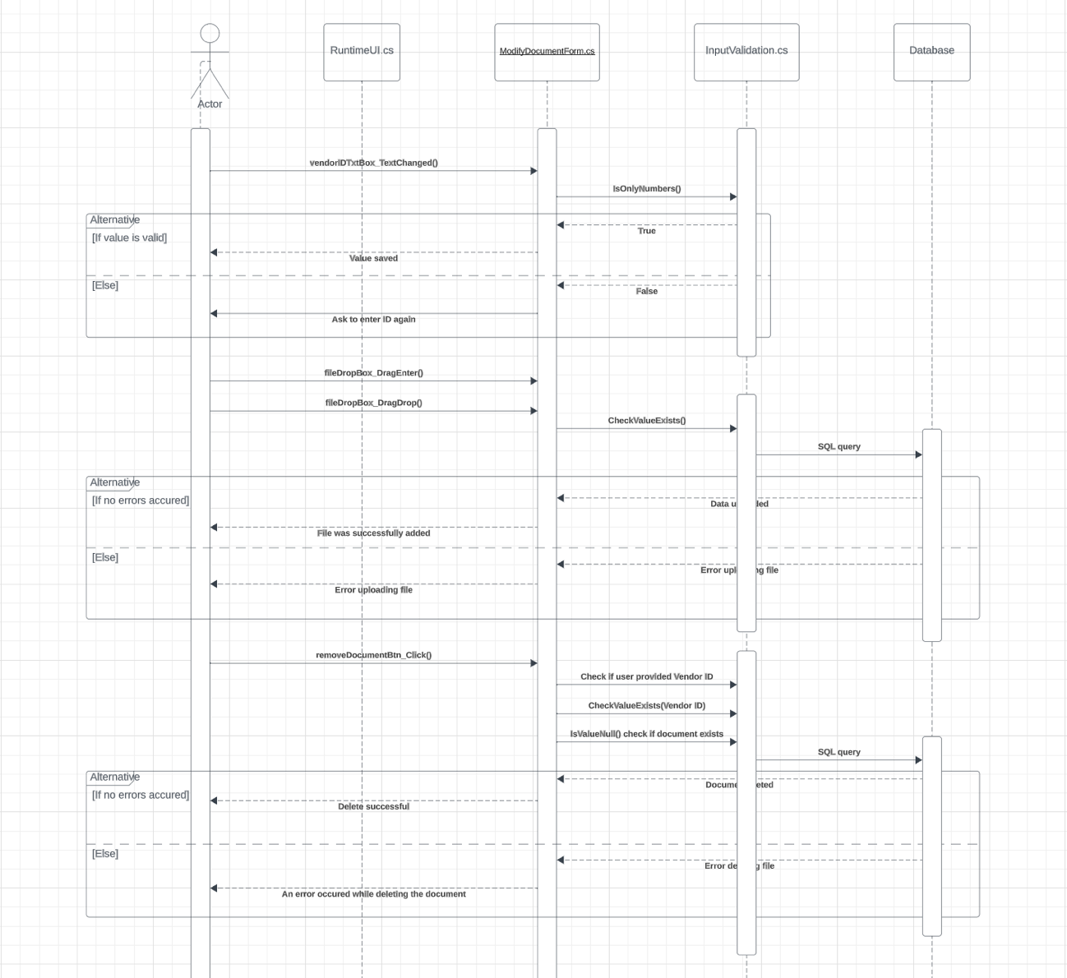

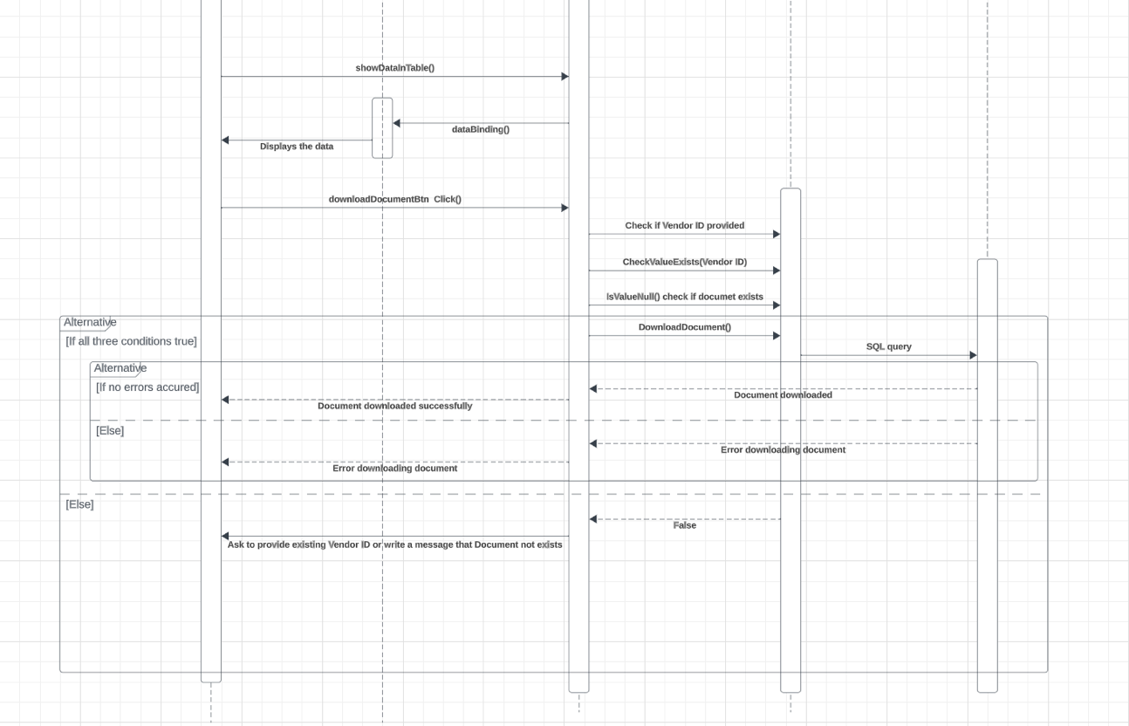

In the provided sequence diagram, describes the process of Adding, Removing and Accessing/Downloading the Vendor documents. At first, Actor is required to provide Vendor ID, which is processed by validation before used. After that, Actor can Add the document, by drag and dropping it in the special box, Remove the document, and Download it. Each button access the database and validates the input.

#### 4.3.1.2 Class diagram

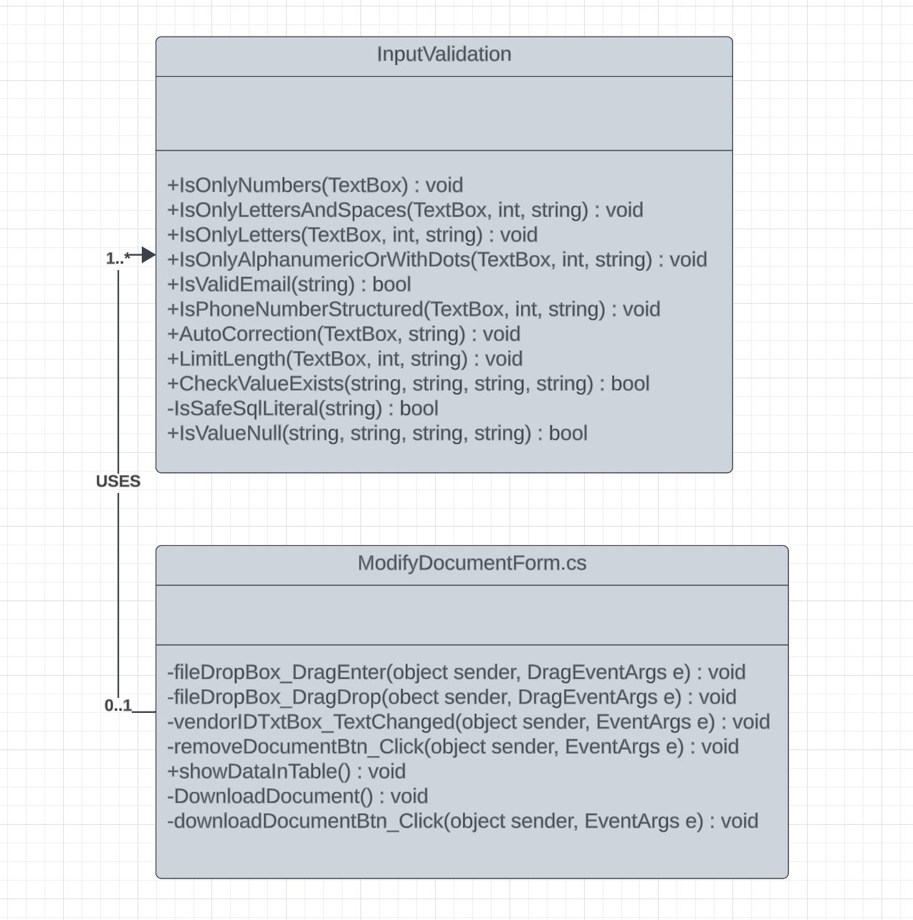The provided Class diagram shows that a user story involves the use of two classes. The first class, called “ModifyDocumentForm.cs” serves as a front end class, for displaying information and interacting with the user. The second class, “InputValidation.cs” plays a role in managing data validation before it is used. Moreover, these classes have a “one to many” relationship indicating that “InputValidation.cs” is utilized many times, within the scope of “ModifyClientForm.cs.”

### Implementation

1. using System;
2. using System.Collections.Generic;
3. using System.ComponentModel;
4. using System.Data;
5. using System.Data.SqlClient;
6. using System.Drawing;
7. using System.IO;
8. using System.Linq;
9. using System.Text;
10. using System.Threading.Tasks;
11. using System.Windows.Forms;
12. namespace CitiSoft
13. {
14. public partial class ModifyDocumentsForm : Form
15. {
16. public ModifyDocumentsForm()
17. {
18. InitializeComponent();
19. InitializeDragDrop();
20. }
21. private void InitializeDragDrop()
22. {
23. fileDropPBox.AllowDrop = true;
24. fileDropPBox.DragEnter += new DragEventHandler(fileDropPBox_DragEnter);
25. fileDropPBox.DragDrop += new DragEventHandler(fileDropPBox_DragDrop);
26. }
27. // the following two methods are used to enable drag and drop functionality to upload document
28. private void fileDropPBox_DragEnter(object sender, DragEventArgs e)
29. {
30. if (e.Data.GetDataPresent(DataFormats.FileDrop))
31. e.Effect = DragDropEffects.Copy;
32. }
33. // adds the dropped file to the database
34. private void fileDropPBox_DragDrop(object sender, DragEventArgs e)
35. {
36. // checks if the user provided Vendor ID
37. if (vendorIDTxtBox.Text == "")
38. {
39. MessageBox.Show("Please provide vendor ID first");
40. return;
41. }
42. // checks if the user provided wrong Vendor ID
43. if (!InputValidation.CheckValueExists(DataBaseManager.citiSoftDatabaseConnectionString, "VendorInfo", "vid", vendorIDTxtBox.Text))
44. {
45. MessageBox.Show("Provided vendor ID does not exist");
46. vendorIDTxtBox.Text = string.Empty;
47. return;
48. }
49. string[] files = (string[])e.Data.GetData(DataFormats.FileDrop);
50. foreach (var file in files)
51. {
52. try
53. {
54. byte[] fileData = File.ReadAllBytes(file);
55. string fileName = $"{vendorIDTxtBox.Text}_{Path.GetFileName(file)}"; // Include Vendor ID in the file name
56. using (SqlConnection connection = new SqlConnection(DataBaseManager.citiSoftDatabaseConnectionString))
57. {
58. string query = "UPDATE VendorInfo SET docAttach = @Data, docType = @FileName WHERE vid = @VendorID";
59. using (SqlCommand command = new SqlCommand(query, connection))
60. {
61. command.Parameters.Add("@Data", SqlDbType.VarBinary, -1).Value = fileData;
62. command.Parameters.AddWithValue("@VendorID", vendorIDTxtBox.Text);
63. command.Parameters.AddWithValue("@FileName", fileName);
64. connection.Open();
65. command.ExecuteNonQuery();
66. }
67. }
68. MessageBox.Show("File was successfully added");
69. vendorIDTxtBox.Text = string.Empty;
70. }
71. catch (Exception exc)
72. {
73. MessageBox.Show("Error uploading file" + exc);
74. vendorIDTxtBox.Text = string.Empty;
75. }
76. }
77. }
78. private void vendorIDTxtBox_TextChanged(object sender, EventArgs e)
79. {
80. TextBox textBox = sender as TextBox;
81. InputValidation.IsOnlyNumbers(textBox);
82. }
83. // removes the attached document if it exists
84. private void removeDocumentBtn_Click(object sender, EventArgs e)
85. {
86. // checks if the user provied Vendor ID
87. if (vendorIDTxtBox.Text == "")
88. {
89. MessageBox.Show("Please provide vendor ID first");
90. return;
91. }
93. // checks if the user provided wrong Vendor ID
94. if (!InputValidation.CheckValueExists(DataBaseManager.citiSoftDatabaseConnectionString, "VendorInfo", "vid", vendorIDTxtBox.Text))
95. {
96. MessageBox.Show("Vendor ID you have provided does not exist");
97. vendorIDTxtBox.Text = string.Empty;
98. return;
99. }
100. if (InputValidation.IsValueNull(DataBaseManager.citiSoftDatabaseConnectionString, "VendorInfo", "docAttach", vendorIDTxtBox.Text))
101. {
102. MessageBox.Show("This Vendor has no document attached");
103. vendorIDTxtBox.Text = string.Empty;
104. return;
105. }
106. using (SqlConnection connection = new SqlConnection(DataBaseManager.citiSoftDatabaseConnectionString))
107. {
108. connection.Open();
109. SqlTransaction transaction = connection.BeginTransaction();
110. try
111. {
112. using (SqlCommand command = new SqlCommand("UPDATE VendorInfo SET docAttach = NULL WHERE vid = @VendorID;", connection, transaction))
113. {
114. // uses parameterizing to prevent from SQL injections
115. command.Parameters.AddWithValue("@VendorID", vendorIDTxtBox.Text);
116. int rowsAffected = command.ExecuteNonQuery();
117. if (rowsAffected > 0)
118. {
119. MessageBox.Show("Delete successful.");
120. transaction.Commit(); // Only commit if no errors occurred
121. vendorIDTxtBox.Text = string.Empty;
122. }
123. else
124. {
125. MessageBox.Show("No document deleted. It's possible that the vendor ID did not exist.");
126. transaction.Rollback(); // Rollback if no rows affected
127. vendorIDTxtBox.Text = string.Empty;
128. }
129. }
130. }
131. catch (SqlException)
132. {
133. transaction.Rollback(); // Rollback on error
134. MessageBox.Show("An error occurred while deleting the document");
135. vendorIDTxtBox.Text = string.Empty;
136. }
137. }
138. }
139. // downloads a document into the user's PC
140. private void DownloadDocument()
141. {
142. using (SqlConnection connection = new SqlConnection(DataBaseManager.citiSoftDatabaseConnectionString))
143. {
144. connection.Open();
145. SqlTransaction transaction = connection.BeginTransaction();
146. try
147. {
148. using (SqlCommand command = new SqlCommand("SELECT docAttach, docType FROM VendorInfo WHERE vid = @VendorID", connection, transaction))
149. {
150. command.Parameters.AddWithValue("@VendorID", vendorIDTxtBox.Text);
151. using (SqlDataReader reader = command.ExecuteReader())
152. {
153. if (reader.Read())
154. {
155. byte[] documentData = (byte[])reader["docAttach"];
156. string fileName = reader["docType"].ToString();
157. // Use SaveFileDialog to let the user choose the save location and file name
158. using (SaveFileDialog saveFileDialog = new SaveFileDialog())
159. {
160. saveFileDialog.FileName = fileName;
161. DialogResult result = saveFileDialog.ShowDialog();
162. if (result == DialogResult.OK && !string.IsNullOrWhiteSpace(saveFileDialog.FileName))
163. {
164. // Save document to the selected file
165. File.WriteAllBytes(saveFileDialog.FileName, documentData);
166. MessageBox.Show("Document downloaded successfully.", "Success", MessageBoxButtons.OK, MessageBoxIcon.Information);
167. transaction.Commit();
168. }
169. else
170. {
171. MessageBox.Show("Download canceled by the user.", "Information", MessageBoxButtons.OK, MessageBoxIcon.Information);
172. }
173. }
174. }
175. else
176. {
177. MessageBox.Show($"No data found for Vendor ID: {vendorIDTxtBox.Text}", "Information", MessageBoxButtons.OK, MessageBoxIcon.Information);
178. }
179. }
180. }
181. }
182. catch (Exception ex)
183. {
184. MessageBox.Show("Error downloading document: " + ex.Message, "Error", MessageBoxButtons.OK, MessageBoxIcon.Error);
185. transaction.Rollback();
186. }
187. }
188. }
189. // Uses a small validation before download a document
190. private void downloadDocumentBtn_Click(object sender, EventArgs e)
191. {
192. // checks if the user provided Vendor ID
193. if (vendorIDTxtBox.Text == "")
194. {
195. MessageBox.Show("Please provide vendor ID first");
196. return;
197. }
198. // checks if the user provided existing Vendor ID
199. if (!InputValidation.CheckValueExists(DataBaseManager.citiSoftDatabaseConnectionString, "VendorInfo", "vid", vendorIDTxtBox.Text))
200. {
201. MessageBox.Show("Provided vendor ID does not exist");
202. vendorIDTxtBox.Text = string.Empty;
203. return;
204. }
205. // checks if the Vendor has any documents
206. if (InputValidation.IsValueNull(DataBaseManager.citiSoftDatabaseConnectionString, "VendorInfo", "docAttach", vendorIDTxtBox.Text))
207. {
208. MessageBox.Show("This Vendor has no document attached");
209. vendorIDTxtBox.Text = string.Empty;
210. return;
211. }
212. DownloadDocument();
213. }
214. }
215. }

## 4.4 User story 3: As a (Admin, Manager, User), I can access vendor documents

### 4.4.1 Design

#### 4.4.1.1 Sequence diagram

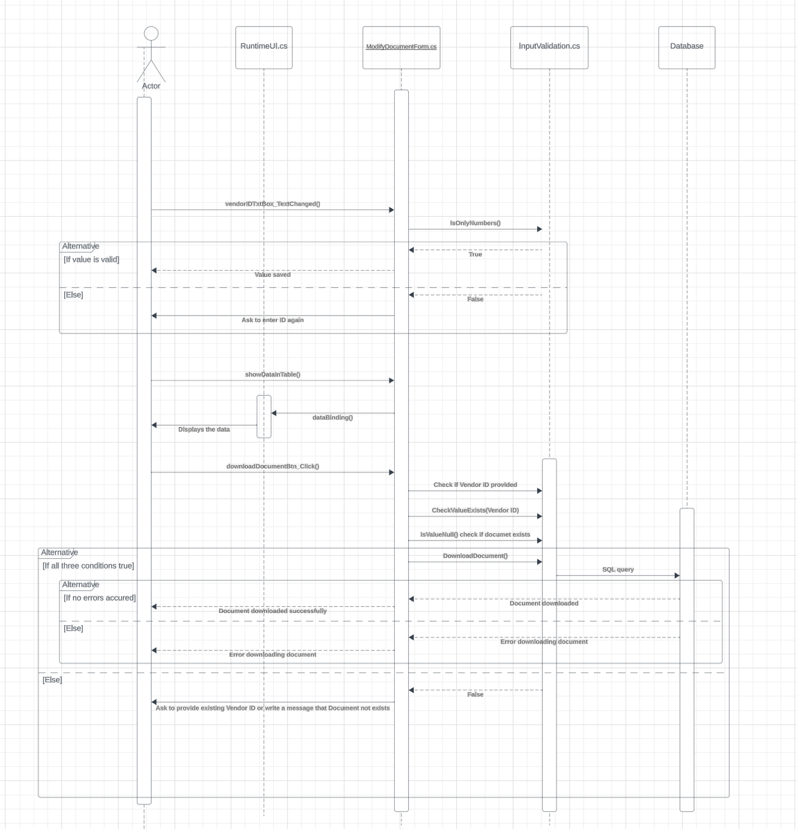

In the provided sequence diagram, the process of accessing/downloading documents is described. Admin/Manager/User first is required to provide Vendor ID, which is validated before used. After that Admin/Manager/User can view all data about Vendor, buy using showDataInTable() method, which displays the content of table, using another method of RuntimeUI.cs class, dataBinding(). In the end, Actor can press the download button, which uses its event handler, the downloadDocumentBtn_Click() that validates Vendor ID, and sends SQL query to download the document data from the database, displaying the result to the Actor.

#### 4.4.1.2 Class diagram

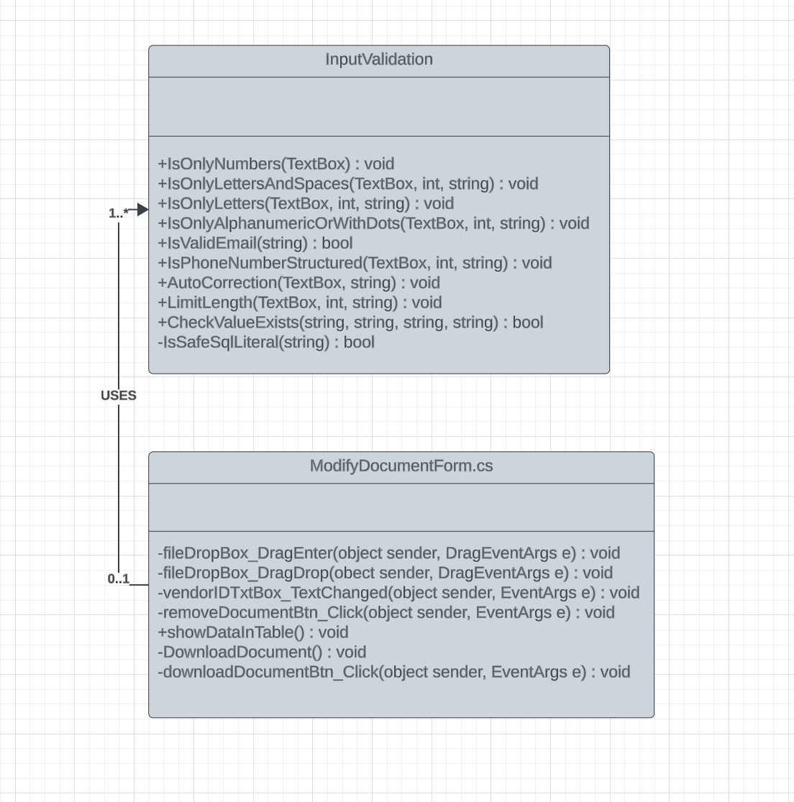

This is the same Class diagram which is used in User story 3. The relationships between these two classes is one-to-many, which means that ModifyDocumentForm.cs uses InputValidation many times.

### Implementation

using System;

using System.Collections.Generic;

using System.ComponentModel;

using System.Data;

using System.Data.SqlClient;

using System.Drawing;

using System.IO;

using System.Linq;

using System.Text;

using System.Threading.Tasks;

using System.Windows.Forms;

namespace CitiSoft

{

public partial class ModifyDocumentsForm : Form

{

public ModifyDocumentsForm()

{

InitializeComponent();

InitializeDragDrop();

}

private void InitializeDragDrop()

{

fileDropPBox.AllowDrop = true;

fileDropPBox.DragEnter += new DragEventHandler(fileDropPBox_DragEnter);

fileDropPBox.DragDrop += new DragEventHandler(fileDropPBox_DragDrop);

}

// the following two methods are used to enable drag and drop functionality to upload document

private void fileDropPBox_DragEnter(object sender, DragEventArgs e)

{

if (e.Data.GetDataPresent(DataFormats.FileDrop))

e.Effect = DragDropEffects.Copy;

}

// adds the dropped file to the database

private void fileDropPBox_DragDrop(object sender, DragEventArgs e)

{

// checks if the user provided Vendor ID

if (vendorIDTxtBox.Text == "")

{

MessageBox.Show("Please provide vendor ID first");

return;

}

// checks if the user provided wrong Vendor ID

if (!InputValidation.CheckValueExists(DataBaseManager.citiSoftDatabaseConnectionString, "VendorInfo", "vid", vendorIDTxtBox.Text))

{

MessageBox.Show("Provided vendor ID does not exist");

vendorIDTxtBox.Text = string.Empty;

return;

}

string[] files = (string[])e.Data.GetData(DataFormats.FileDrop);

foreach (var file in files)

{

try

{

byte[] fileData = File.ReadAllBytes(file);

string fileName = $"{vendorIDTxtBox.Text}_{Path.GetFileName(file)}"; // Include Vendor ID in the file name

using (SqlConnection connection = new SqlConnection(DataBaseManager.citiSoftDatabaseConnectionString))

{

string query = "UPDATE VendorInfo SET docAttach = @Data, docType = @FileName WHERE vid = @VendorID";

using (SqlCommand command = new SqlCommand(query, connection))

{

command.Parameters.Add("@Data", SqlDbType.VarBinary, -1).Value = fileData;

command.Parameters.AddWithValue("@VendorID", vendorIDTxtBox.Text);

command.Parameters.AddWithValue("@FileName", fileName);

connection.Open();

command.ExecuteNonQuery();

}

}

MessageBox.Show("File was successfully added");

vendorIDTxtBox.Text = string.Empty;

}

catch (Exception exc)

{

MessageBox.Show("Error uploading file" + exc);

vendorIDTxtBox.Text = string.Empty;

}

}

}

private void vendorIDTxtBox_TextChanged(object sender, EventArgs e)

{

TextBox textBox = sender as TextBox;

InputValidation.IsOnlyNumbers(textBox);

}

// removes the attached document if it exists

private void removeDocumentBtn_Click(object sender, EventArgs e)

{

// checks if the user provied Vendor ID

if (vendorIDTxtBox.Text == "")

{

MessageBox.Show("Please provide vendor ID first");

return;

}

// checks if the user provided wrong Vendor ID

if (!InputValidation.CheckValueExists(DataBaseManager.citiSoftDatabaseConnectionString, "VendorInfo", "vid", vendorIDTxtBox.Text))

{

MessageBox.Show("Vendor ID you have provided does not exist");

vendorIDTxtBox.Text = string.Empty;

return;

}

if (InputValidation.IsValueNull(DataBaseManager.citiSoftDatabaseConnectionString, "VendorInfo", "docAttach", vendorIDTxtBox.Text))

{

MessageBox.Show("This Vendor has no document attached");

vendorIDTxtBox.Text = string.Empty;

return;

}

using (SqlConnection connection = new SqlConnection(DataBaseManager.citiSoftDatabaseConnectionString))

{

connection.Open();

SqlTransaction transaction = connection.BeginTransaction();

try

{

using (SqlCommand command = new SqlCommand("UPDATE VendorInfo SET docAttach = NULL WHERE vid = @VendorID;", connection, transaction))

{

// uses parameterizing to prevent from SQL injections

command.Parameters.AddWithValue("@VendorID", vendorIDTxtBox.Text);

int rowsAffected = command.ExecuteNonQuery();

if (rowsAffected > 0)

{

MessageBox.Show("Delete successful.");

transaction.Commit(); // Only commit if no errors occurred

vendorIDTxtBox.Text = string.Empty;

}

else

{

MessageBox.Show("No document deleted. It's possible that the vendor ID did not exist.");

transaction.Rollback(); // Rollback if no rows affected

vendorIDTxtBox.Text = string.Empty;

}

}

}

catch (SqlException)

{

transaction.Rollback(); // Rollback on error

MessageBox.Show("An error occurred while deleting the document");

vendorIDTxtBox.Text = string.Empty;

}

}

}

// downloads a document into the user's PC

private void DownloadDocument()

{

using (SqlConnection connection = new SqlConnection(DataBaseManager.citiSoftDatabaseConnectionString))

{

connection.Open();

SqlTransaction transaction = connection.BeginTransaction();

try

{

using (SqlCommand command = new SqlCommand("SELECT docAttach, docType FROM VendorInfo WHERE vid = @VendorID", connection, transaction))

{

command.Parameters.AddWithValue("@VendorID", vendorIDTxtBox.Text);

using (SqlDataReader reader = command.ExecuteReader())

{

if (reader.Read())

{

byte[] documentData = (byte[])reader["docAttach"];

string fileName = reader["docType"].ToString();

// Use SaveFileDialog to let the user choose the save location and file name

using (SaveFileDialog saveFileDialog = new SaveFileDialog())

{

saveFileDialog.FileName = fileName;

DialogResult result = saveFileDialog.ShowDialog();

if (result == DialogResult.OK && !string.IsNullOrWhiteSpace(saveFileDialog.FileName))

{

// Save document to the selected file

File.WriteAllBytes(saveFileDialog.FileName, documentData);

MessageBox.Show("Document downloaded successfully.", "Success", MessageBoxButtons.OK, MessageBoxIcon.Information);

transaction.Commit();

}

else

{

MessageBox.Show("Download canceled by the user.", "Information", MessageBoxButtons.OK, MessageBoxIcon.Information);

}

}

}

else

{

MessageBox.Show($"No data found for Vendor ID: {vendorIDTxtBox.Text}", "Information", MessageBoxButtons.OK, MessageBoxIcon.Information);

}

}

}

}

catch (Exception ex)

{

MessageBox.Show("Error downloading document: " + ex.Message, "Error", MessageBoxButtons.OK, MessageBoxIcon.Error);

transaction.Rollback();

}

}

}

// Uses a small validation before download a document

private void downloadDocumentBtn_Click(object sender, EventArgs e)

{

// checks if the user provided Vendor ID

if (vendorIDTxtBox.Text == "")

{

MessageBox.Show("Please provide vendor ID first");

return;

}

// checks if the user provided existing Vendor ID

if (!InputValidation.CheckValueExists(DataBaseManager.citiSoftDatabaseConnectionString, "VendorInfo", "vid", vendorIDTxtBox.Text))

{

MessageBox.Show("Provided vendor ID does not exist");

vendorIDTxtBox.Text = string.Empty;

return;

}

// checks if the Vendor has any documents

if (InputValidation.IsValueNull(DataBaseManager.citiSoftDatabaseConnectionString, "VendorInfo", "docAttach", vendorIDTxtBox.Text))

{

MessageBox.Show("This Vendor has no document attached");

vendorIDTxtBox.Text = string.Empty;

return;

}

DownloadDocument();

}

}

}

# Commits

Repository: <https://github.com/yash-akbari/CitiSoft>

Github account used: Ilyas9282

Main Github account: Ilyas2695

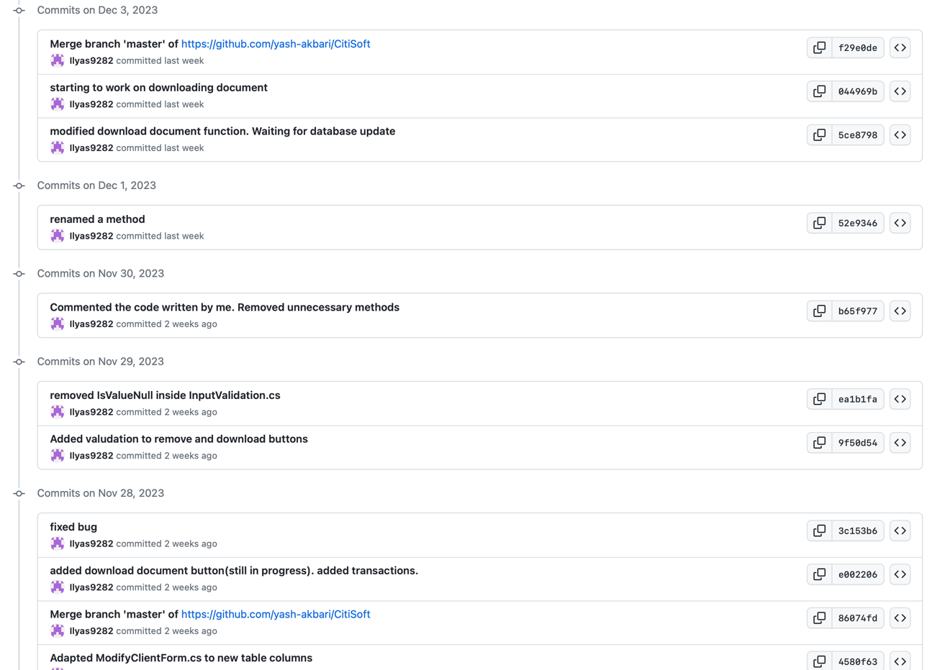

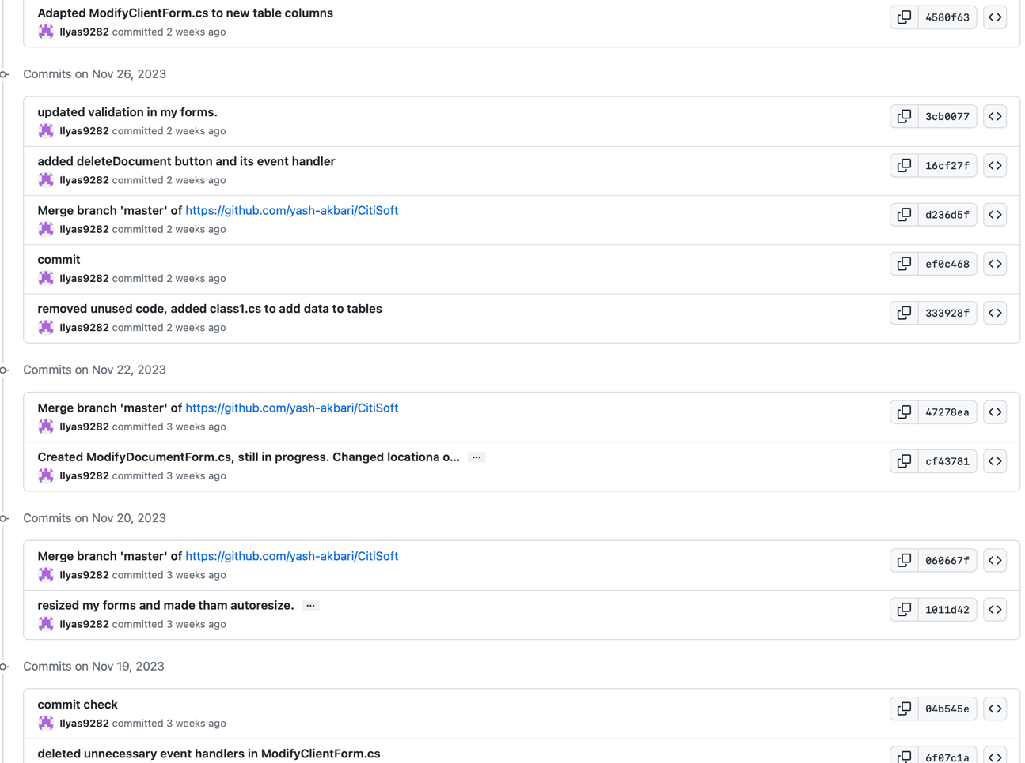

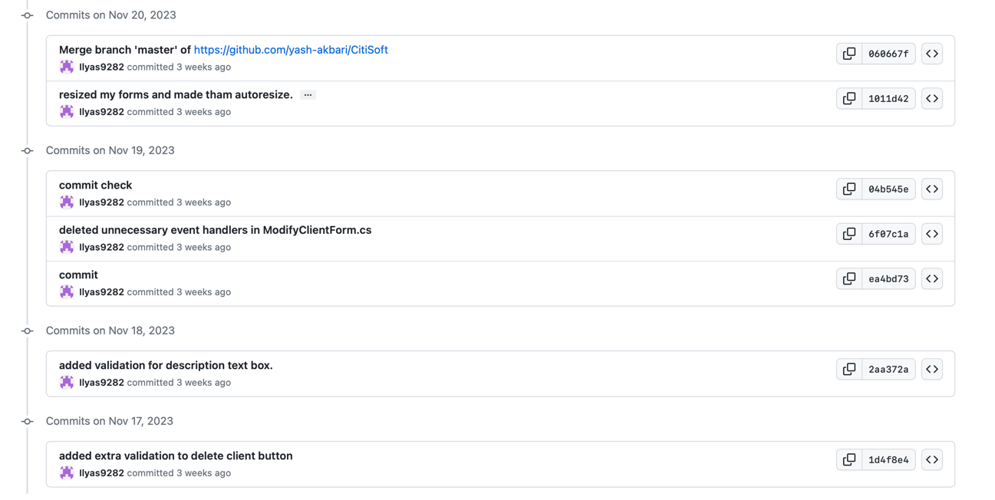

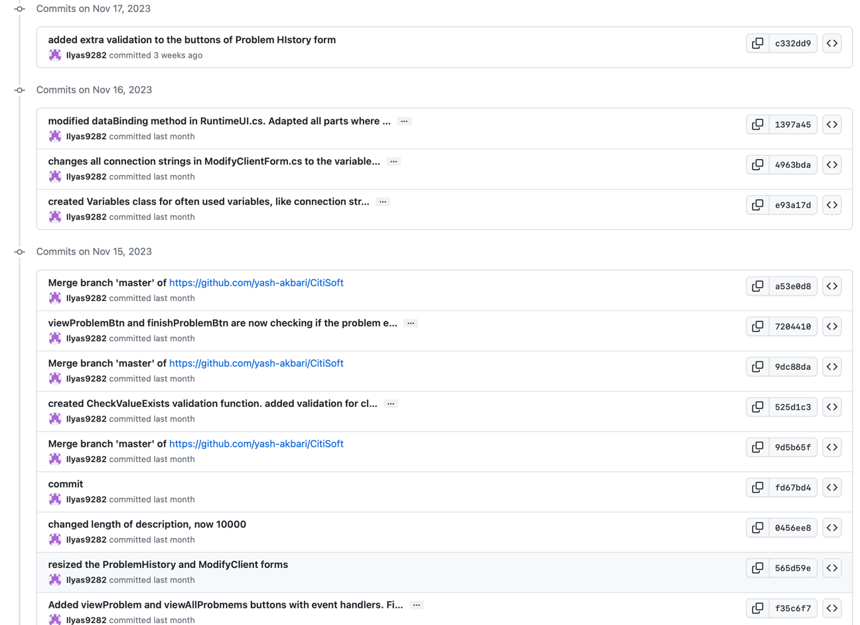

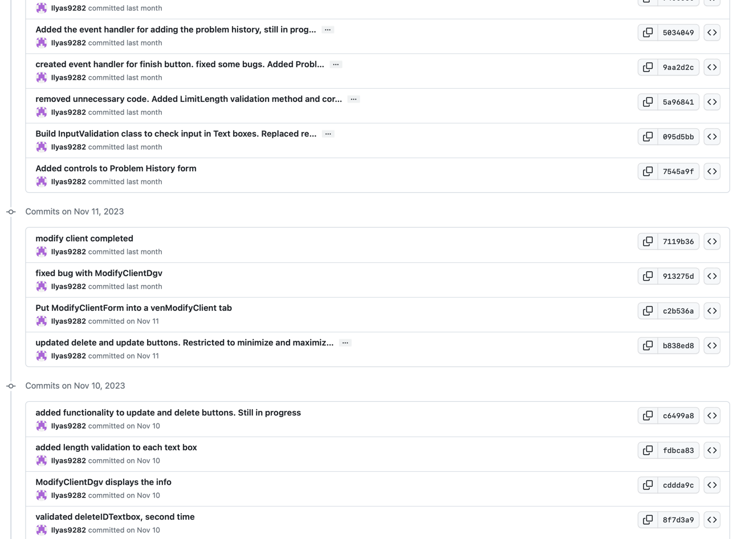

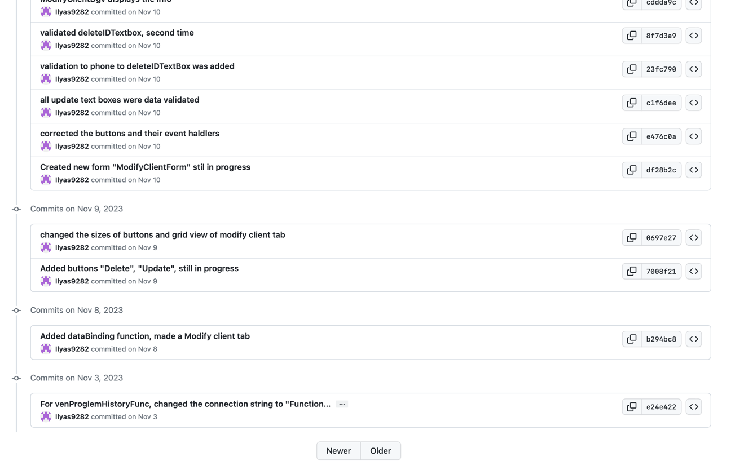

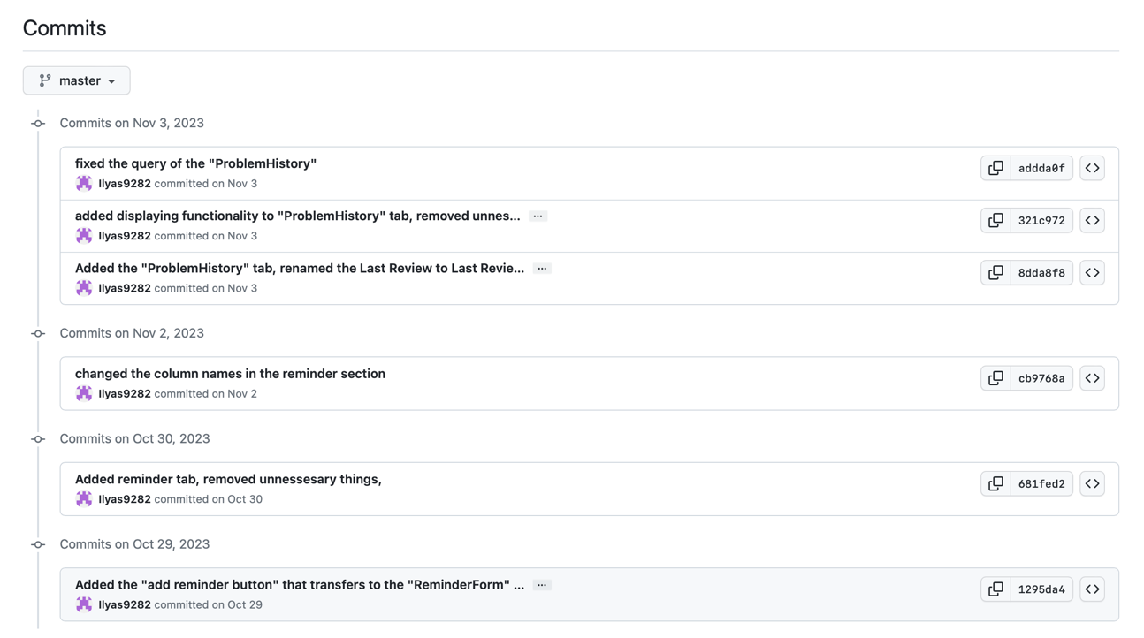

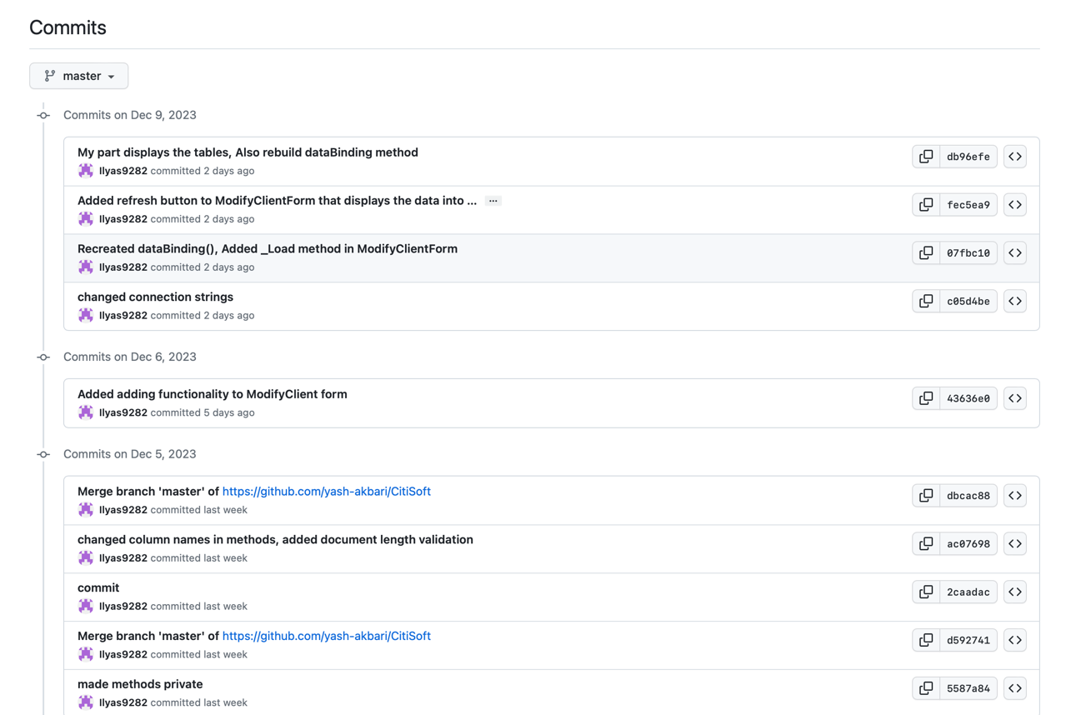

# Testing

|  |  |  |  |  |
| --- | --- | --- | --- | --- |
| **Test No** | **Test (Description)** | **Expected Result** | **Actual Result** | **Pass/Fail** |
| 1. 1 | IsOnlyNumbers()  Provide input containing characters that are not numbers | Handle wrong input | Handled wrong input | PASS |
| 1. 2 | IsOnlyLettersAndSpaces()  Provide wrong input | Throw an error message | Threw an error message | PASS |
| 1. 3 | IsOnlyLettersAndSpaces()  Provide rignt input | Allow input | Allowed input | PASS |
| 1. 4 | IsOnlyLetters()  Provide alphanumeric input | Handle wrong input | Handled wrong input | PASS |
| 1. 5 | IsOnlyLetters()  Provide input with spaces | Handle wrong input | Handled wrong input | PASS |
| 1. 6 | IsOnlyLetters()  Provide right input | Allow input | Allowed input | PASS |
| 1. 7 | IsOnlyAlphanumericOrWithDots()  Provide wrong length on input | Handle wrong input | Handled wrong input | PASS |
| 1. 8 | IsOnlyAlphanumericOrWithDots()  Provide wrong input | Handle wrong input | Handled wrong input | PASS |
| 1. 9 | IsValidEmail()  Provide wrong length of email | Handle wrong input | Handled wrong input | PASS |
| 1. 10 | IsValidEmail()  Provide wrong structure of emal | Handle wrong email | Handled wrong email | PASS |
| 1. 11 | IsValidEmail()  Provide right email structure | Allow email | Allowed email | PASS |
| 1. 12 | IsPhoneNumberStructured()  Provide wrong length input | Handle wrong input | Handled wrong input | PASS |
| 1. 13 | IsPhoneNumberStructured()  Provide wrong text | Handle wrong input | Handled wrong input | PASS |
| 1. 14 | IsPhoneNumberStructured()  Provide right text | Allow text | Allowed text | PASS |
| 1. 15 | AutoCorrection()  Will it remove last character is the input is wrong | Remove the last character | Removed last character | PASS |
| 1. 16 | LimitLength()  Will it show error message and use AutoCorrection() method | Show an error message and use AutoCorrection method | Show an error message and used AutoCorrection method | PASS |
| 1. 17 | CheckValueExists()  Check if the column and value are safe sql literals | Handle an error | Handled an error | PASS |
| 1. 18 | CheckValueExists()  Check if the value exists in the table’s column | Return TRUE | Returned TRUE | PASS |
| 1. 19 | CheckValueExists()  Provide the value that exist in the table’s column | Return FALSE | Returned FALSE | PASS |
| 1. 20 | IsSafeSqlLiteral()  Provide sql key word a parameter | Return False | Return False | PASS |
| 1. 21 | updateClientBtn_Click()  fill in not all text boxes and provide client id | Update client’s info with filled in text boxes and show message | Updated client’s info with filled in text boxes and show message | PASS |
| 1. 22 | updateClentBtn_Click()  provide only client id | Throw a message that user must fill in other text boxes | Threw a message user must fill in other text boxes | PASS |
| 1. 23 | updateClentBtn_Click()  provide non existing client id | Throw a message that client with provided id does not exist | Threw a message that client with provided id does not exist | PASS |
| 1. 24 | updateClientBtn_Click()  fill in all text boxes and provide client id | Update client’s info with filled in text boxes and show message | Updated client’s info with filled in text boxes and show message | PASS |
| 1. 25 | updateClientBtn_Click()  do not provide client id | Throw a message that user must provide client id | Threw a message that user must provide client id | PASS |
|  | updateClientBtn_Click()  check if it uses AddClient() if all values were provided | Use AddClient() method which inserts the data into the database | Used AddClient() method which inserts the data into the database | PASS |
| 1. 26 | deleteClientBtn_Click()  do not provide client id | Throw a message that user must provide client id | Threw a message that user must provide client id | PASS |
| 1. 27 | deleteClientBtn_Click()  provide non existing client id | Throw a message that client with provided id does not exist | Threw a message that client with provided id does not exist | PASS |
| 1. 28 | deleteClientBtn_Click()  provide right client id | Delete the data related to client with provided id, and show a message | Deleted the data related to client with provided id, and show a message | PASS |
| 1. 29 | clientIDTxtbox_TextChanged()  will it use the IsOnlyNumbers method, and validate data | Use IsOnlyNumbers method and validated data | Used IsOnlyNumbers method and validated data | PASS |
| 1. 30 | companyNameTxtBox_TextChanged()  will it use the IsONlyLettersAndSpaces method, and validate data | Use IsONlyLettersAndSpaces method and validated data | Used IsONlyLettersAndSpaces method and validated data | PASS |
| 1. 31 | countryTxtBox_TextChanged()  will it use the IsOnlyLetters method, and validate data | Use IsOnlyLetters method and validated data | Used IsOnlyLetters method and validated data | PASS |
| 1. 32 | cityTxtBox_TextChanged()  will it use the IsOnlyLetters method, and validate data | Use IsOnlyLetters method and validated data | Use IsOnlyLetters method and validated data | PASS |
| 1. 33 | streetTxtBox_TextChanged()  will it use the IsOnlyAlphanumericOrWithDots method, and validate data | Use IsOnlyAlphanumericOrWithDots method and validated data | Used IsOnlyAlphanumericOrWithDots method and validated data | PASS |
| 1. 34 | emailTextBox_KeyDown()  provide email with wrong length | Handle wrong email with wrong length, and show a message | Handled wrong email with wrong length, and show a message | PASS |
| 1. 35 | emailTextBox_KeyDown()  provide worng email structure and use IsValidEmail that checks the email structure | Handle wrong email structure and show a message | Handled wrong email structure and show a message | PASS |
| 1. 36 | emailTextBox_KeyDown()  Provide rignt email structure and use IsValid Email that checks the email structure | Allow email, and show a message | Allowed email, and show a message | PASS |
| 1. 37 | phoneTxtBox_TextChanged()  will it use the IsPHoneNumberStructured method, and validate data | Use IsPHoneNumberStructured method and validated data | Used IsPHoneNumberStructured method and validated data | PASS |
| 1. 38 | deleteIDTxtBox_TextChanged()  will it use the deleteIDTxtBox_TextChenged method, and validate data | Use deleteIDTxtBox_TextChenged method and validated data | Used deleteIDTxtBox_TextChenged method and validated data | PASS |
| 1. 39 | addClientBtn_Click()  do not fill all required text boxes | Throw a message that user must fill in all required text boxes | Threw a message that user must fill in all required text boxes | PASS |
| 1. 40 | addClientBtn_Click()  provide non existing client id | Throw a message provided client id does not exist | Threw a message provided client id does not exist | PASS |
| 1. 41 | addClientBtn_Click()  provide non existing user id | Throw a message provided user id does not exist | Throw a message provided user id does not exist | PASS |
| 1. 42 | addClientBtn_Click()  provide ids, but do not provide description | Throw a message that user must provide some description | Threw a message that user must provide some description | PASS |
| 1. 43 | addClientBtn_Click()  provide everything | Adds a problem to the problem history | Added a problem to the problem history | PASS |
| 1. 44 | addClientBtn_Click()  provide non-existing client id | Throw a message that noting was changed, because client id does not exist | Threw a message that noting was changed, because client id does not exist | PASS |
| 1. 45 | addClientBtn_Click()  provide non-existing user id | Throw a message that noting was changed, because user id does not exist | Threw a message that noting was changed, because user id does not exist | PASS |
| 1. 46 | clientIDPHTxtBox_TextChanged()  will it use IsOnlyNumbers method and validate data | Use IsOnlyNumbers method and validate data | Used IsOnlyNumbers method and validatd data | PASS |
| 1. 47 | problemIDTxtBox_TextChanged()  will it use IsOnlyNumbers method and validate data | Use IsOnlyNumbers method and validate data | Used IsOnlyNumbers method and validatd data | PASS |
| 1. 48 | descriptionTxtBox_TextChanged()  will it use LimitLength method and validate data | Use LimitLength method and validate data | Use LimitLength method and validate data | PASS |
| 1. 49 | userIDPHTxtBox_TextChanged()  will it use IsOnlyNumbers method and validate data | Use IsOnlyNumbers method and validate data | Used IsOnlyNumbers method and validate data | PASS |
| 1. 50 | finishProblemBtn_Click_1()  do not provide problem id | Throw a message that problem id must be provided | Threw a message that problem id must be provided | PASS |
| 1. 51 | finishProblemBtn_Click_1()  provide non existing problem id | Throw a message that provided problem does not exist | Threw a message that provided problem does not exist | PASS |
| 1. 52 | finishProblemBtn_Click_1()  provide everything right | Updates the isClosed value to True, show a message | Updated the isClosed value to True, show a message | PASS |
| 1. 53 | viewProblemBtn_Click()  do not provide problem id | Throw a message that problem id must be provided | Threw a message that problem id must be provided | PASS |
| 1. 54 | viewProblemBtn_Click()  provide non existing problem id | Throw a message that provided problem does not exist | Threw a message that provided problem does not exist | PASS |
| 1. 55 | viewProblemBtn _Click()  provide everything right | Displays the selected problem to the data grid view | Displayed the selected problem to the data grid view | PASS |
| 1. 56 | viewAllProblemsBtn_Click()  check if it uses dataBinding method, and displays columns from ProblemHistory table | Displays the columns | Displayed the columns | PASS |
| 1. 57 | fileDropbox_DragEnter()  check if it validates not provided Vendor ID | Displays the message to provide Vendor ID first | Displayed the message to provide Vendor ID first | PASS |
| 1. 58 | fileDropbox_DragEnter()  check if it validates non-existing Vendor ID | Displays the message to provide existing Vendor ID | Displayed the message to provide existing Vendor ID | PASS |
| 1. 59 | fileDropbox_DragEnter()  check if it saves the dropped file | Saves the dropped file to the database | Saved the dropped file to the database | PASS |
| 1. 61 | vendorIDTxBox_TextChanged()  check if it uses IsOnlyNumbers() method of InputValidation class | Uses IsOnlyNumbers method and validates the data | Used IsOnlyNumbers method and validates the data | PASS |
|  | removeDocumentBtn_Click()  do not provide Vendor ID and click the button | Displays the message that Vendor ID must be provided | Displayed the message that Vendor ID must be provided | PASS |
|  | removeDocumentBtn_Click()  provide non-existing Vendor ID | Displays the message that existing Vendor ID must be provided | Displayed the message that existing Vendor ID must be provided | PASS |
|  | removeDocumentBtn_Click()  provide Vendor ID that does not have document attached and check if it uses IsValueNull() method of InputValidation class | Uses IsValueNull() method and displays the message that Vendor does not have a document | Used IsValueNull() method and displayed the message that Vendor does not have a document | PASS |
|  | removeDocumentBtn_Click()  check if it removes the document | Removes the document | Removed the document | PASS |
|  | DownloadDocument()  check if it downloads a document | Downloads the document | Downloaded the document | PASS |
|  | downloadDocumentBtn_Click()  do not provide Vendor ID | Display the message that Vendor ID must be provided first | Displayed the message that Vendor ID must be provided first | PASS |
|  | downloadDocumentBtn_Click()  provide non-existing Vendor ID | Displays the message that Vendor ID does not exist | Displays the message that Vendor ID does not exist | PASS |
|  | downloadDocumentBtn_Click()  provide Vendor ID that does not have document attached | Displays the message that Vendor ID does not have a document attached | Displayed the message that Vendor ID does not have a document attached | PASS |
|  | downloadDocumentBtn_Click()  check if it uses DownloadDocument() method | Uses the Download Document method | Used the Download Document method | PASS |

# Plan of the Software Maintenance

While programming is an essential tool for solving problems, it also increases the risk of running into known or unknown problems, also known as bugs, when testing. Even with careful manual testing, some bugs might still go unnoticed. Plans for maintenance are therefore essential in order to fix bugs and add new features.

1) There is a security risk because the current database is not encrypted. Strong encryption must be used in order to strengthen data security and prevent unwanted access.

2) The MVC architecture is not followed by CRUD operations in some parts of the programme. To effectively incorporate MVC architecture and improve code maintainability and organisational efficiency, a crucial update is needed.

3) Strict validation procedures must be put in place to guarantee data integrity because there are no checks for adding, removing, or altering data in the database.

4) It is crucial to incorporate a revert function, which functions as an invaluable instrument for retrieving data that has been inadvertently erased or updated. This allows for the complete restoration of data.

5) Since the system does not yet have an import feature, a strong import feature must be created in order to facilitate smooth data integration.

6) There is no way to export vendor or software-specific data. Consequently, the inclusion of an export feature becomes essential for thorough data management.

7) The lack of a backup feature in the system puts data integrity at serious risk. To reduce the possibility of data loss, a reliable backup system must be put in place.

8) Including internet interaction capabilities for bug reports is essential to promote better communication and issue resolution. The effectiveness of the bug tracking and resolution procedures is improved by this feature.

9) Thorough issue tracking is hampered by the lack of a specific system or code to store issue data. Closing this gap is necessary to enable a resolution process that is more comprehensive and efficient.

10) In order to notify users when a vendor's last review period has ended, a notification area must be implemented. This guarantees prompt action, avoiding breakdowns in crucial procedures.

11) To improve data accuracy and integrity and create a more dependable database, a system for identifying duplicate main data must be developed.

12) All data is displayed on a single screen due to current UI design limitations. In the future, the interface will be optimised to present only pertinent data for better data management and user experience.

13) Although the search feature works well, accuracy is occasionally impacted by the display of irrelevant information. Fixing this problem is essential for accurate and efficient search results, which improve system usability in general.

In conclusion, the improvements that have been described, along with the dedication to continuous maintenance, help to build a reliable and effective software system that will not falter in the face of changing obstacles.

# Conclusions

In conclusion this project has been a learning experience, for me as I gained knowledge in Windows Forms, C# and software engineering. Throughout the development process I successfully handled both backend and frontend tasks including database design and wireframing.

To enhance the application;

1. Improve the User Experience (UX) by conducting usability testing.
2. Optimize the code for performance and readability.
3. Strengthen security measures to ensure data protection.
4. Assess scalability to accommodate growth.
5. Enhance documentation to facilitate maintenance.
6. Perform testing. Implement automated testing procedures.
7. Establish a feedback loop with users and stakeholders for improvement.
8. Stay updated with the advancements, in technology.

By prioritizing these aspects we can guarantee the success and relevance of the application in todays evolving software development landscape.

# References

1. Lucid Software, 2018. How to Make a UML Sequence Diagram. [Video]. Available at: <https://youtu.be/pCK6prSq8aw?si=Wq8T9Qa-JC6w2Yku> (Accessed: 22 November 2023)
2. Lucid Software, 2023. UML class diagrams. [Video]. Available at: https://youtu.be/6XrL5jXmTwM?si=t1haMERmnOMnBFxL (Accessed: 23 November 2023)
3. Computer Science source, 2023. Software Engineering – Use Case Diagrams / Descriptions. <https://computersciencesource.wordpress.com/2009/11/22/year-2-software-engineering-use-case-diagrams-descriptions/>, (Accessed: 1 December 2023)
4. Codecademy, 2023. Build Web Apps with ASP.NET. <https://www.codecademy.com/paths/build-web-apps-with-asp-net/tracks/asp-net-i/modules/asp-net-razor-syntax/lessons/razor-pages-syntax-i>, (Accessed: 10 October 2023)
5. IAmTimCorey, 2022. Intro to Windows Forms (WinForms) in .NET 6. <https://youtu.be/0zLZQesgV5o?si=BEuRfiE7VSQNh4da>, (Accessed: 20 October 2023)
6. Forbes, 2023. What is Waterfall Methodology? And Can It Help Your Project Management Strategy?. <https://www.forbes.com/uk/advisor/business/what-is-waterfall-methodology/>, (Accessed 15 October)